

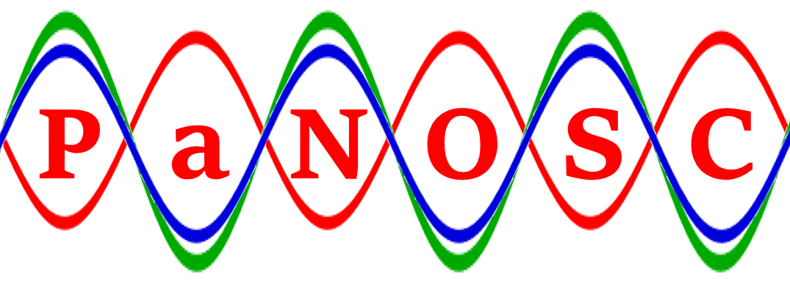

|  |  |
| --- | --- |
| **Proposal name** | **PaNOSC** |
| **Proposal full name** | **Photon and Neutron Open Science Cloud** |
| **H2020 Call** | **INFRAEOSC-04-2018** |
| **Coordinator** | **Andrew Götz (andy.gotz@esrf.fr)** |
| **Coordinating organisation** | **ESRF** |
| **Deliverable Name** | **D1.1 Project Initiation Documentation** |
| **Reviewed by** | **Andrew Götz (ESRF) on 30/1/2019** |
| **Reviewed by** | **Jean-Francois Perrin (ILL) on 30/01/2019** |

**List of participants**

|  |  |  |
| --- | --- | --- |
| **Participant No** | **Participant organisation name** | **Country** |
| 1 | European Synchrotron Radiation Facility (ESRF) | France |
| 2 | Institut Laue-Langevin (ILL) | France |
| 3 | European XFEL (XFEL.EU) | Germany |
| 4 | The European Spallation Source (ESS) | Sweden |
| 5 | Extreme Light Infrastructure Delivery Consortium (ELI-DC) | Belgium |
| 6 | Central European Research Infrastructure Consortium (CERIC-ERIC) | Italy |
| 7 | EGI Foundation (EGI.eu) | Netherlands |

Contents

Introduction 4

Business Case 4

Project Plan 4

Methodology 5

Work Package 1 Approach 6

Work Package 2 Approach 6

Work Package 3 Approach 7

Work Package 4 Approach 7

Work Package 5 Approach 8

Work Package 6 Approach 8

Work Package 7 Approach 9

Work Package 8 Approach 9

Work Package 9 Approach 11

PaNOSC’s Tasks, Deliverables and Milestones 11

Team Structure 14

Communication Management Strategy 16

Internal Communication 16

External Communication 16

Risk Management Strategy 18

Quality Management Strategy 19

Quality Reviews 19

Configuration Management Strategy 19

Issue Log 19

Management Key Performance Indicators 19

Work Package Key Performance Indicators 20

Appendix I: Work Package descriptions 21

Work Package 1: Management 21

Work package 2: Data Policy and Stewardship 22

Work package 3: Data Catalog Services 24

Work package 4: Data Analysis Services 26

Feedback from the pilot 27

Software distribution repository 28

Reference implementation documentation 28

EOSC Authentication and Authorization Infrastructure 28

Data sharing 28

Common platform 28

Local use of Jupyter Notebook based data analysis services 29

JupyterHub for multi-user remote data analysis 29

Binder for data analysis and FAIR principles 29

Towards reproducible publications 30

Exploitation of emerging technology and methods 30

Work package 5: VIrtual Neutron and x-raY Laboratory (VINYL) 31

Work package 6: EOSC integration 34

Work package 7: Sustainability 37

Work package 8: Staff and User Training 38

Work package 9: Outreach/Communication and Dissemination/Impact 41

Appendix II: Members of the Executive Board and Project Management Committee 45

Appendix III: List of Issues 46

# Introduction

The Project Initiation Documentation (PID) is a set of documents that brings together key information needed to start the project on a sound basis and that conveys the information to all concerned with the project [PRINCE2 Manual page 309].

This document is a snapshot for what is known of the project at the time of writing, however PaNOSC will keep a copy for internal use that will evolve with the project.

# Business Case

The Photon and Neutron Open Science Cloud (PaNOSC) is a project to align the efforts of the existing and new photon and neutron sources to link up to the EOSC. The project members are the following ESFRI roadmap research infrastructures: European Synchrotron Radiation Facility (ESRF), Institut Laue-Langevin (ILL), European X-ray Free Electron Laser (XFEL.EU), Extreme Light Infrastructure (ELI), The European Spallation Source ERIC (ESS), and the Central European Research Infrastructure Consortium (CERIC-ERIC), which to a large extent have a shared user community. The consortium also includes the EGI Foundation (EGI.eu) e-infrastructure as partner.

PaNOSC is coordinated by the ESRF.

The European Commission has funded PaNOSC within the H2020-INFRAESOC-2018-2 call to a total estimated amount of 11,953,516.99 €.

The main objectives of PaNOSC are:

1. **Participate** in the construction of the EOSC by linking with the e-infrastructures and other ESFRI clusters.
2. **Make** scientific data produced at Europe’s major Photon and Neutron sources fully compatible with the FAIR principles.
3. **Generalise** the adoption ofopen data policies, standard metadata and data stewardship from 15 photon and neutron RIs and physics institutes across Europe.
4. **Provide** innovative data services to the users of these facilities locally and the scientific community at large via the European Open Science Cloud (EOSC).
5. **Increase** the impact of RIs by ensuring data from user experiments can be used beyond the initial scope.
6. **Share** the outcomes with the national RIs who are observers in the proposal and the community at large to promote the adoption of FAIR data principles, data stewardship and the EOSC.

# Project Plan

PaNOSC’s different streams of work have been split up in nine different work packages (each one with several tasks and deliverables):

WP1 – Management

WP2 – Data Policy and Stewardship

WP3 – Data Catalog Services

WP4 – Data Analysis Services

WP5 – Virtual Neutron and x-Ray Laboratory

WP6 – EOSC Integration

WP7 – Sustainability

WP8 – Staff and User Training

WP9 – Outreach/Communication and Dissemination/Impact

Each work package will have a single leader in charge of organising and delivering its work.

Each work package tackles an area of work required for PaNOSC to be successful, with links between each other, therefore good communication between different work packages will be required.

PaNOSC will use GitHub (<https://github.com/panosc-eu>) as a main information repository in the project, as explained in the Configuration Management Strategy section of this document.

Appendix I lists the work packages descriptions with the tasks and deliverables presented in the proposal. On top of these a refined plan for each work package will be created during the first six months of the project execution.

## Methodology

The methodology of the PaNOSC project is based on the following steps:

1. **Use** the expertise of the experienced partners in the cluster (ILL, ESRF, XFEL.EU) who have implemented solutions for data management and stewardship at TRL8 and TRL9 levels to bring the other partners (ELI, CERIC-ERIC and ESS) up to the same level  
   
2. **Generalise** data policies and stewardship at all partner sites so that the data and metadata , obtained as the result of academic access to the infrastructure (i.e. does not concern industry access), can be curated and archived and be made open (after an embargo period)  
   
3. **Standardise** metadata by following community standards like NeXus. Enhance existing standards where necessary via the community decision making procedure for doing so.  
   
4. **Federate** all metadata catalogs so they can be searched from one portal and harvested by the EOSC portals (OpenAIRE-Advance and EUDAT)  
   
5. **Implement** innovative data services based on Jupyter notebooks and desktop applications as TRL9 services which can be run locally at each partner site (for datasets too big to transport) and on third party infrastructure participating in EOSC when data could be easily move.  
   
6. **Fully** integrate these services into the EOSC as part of the EOSC applications portal and use the EOSC compute resources reserved for PaNOSC  
   
7. **Develop** with GÉANT a federated Authentication and Authorization Infrastructure (AAI) solution compatible with the EOSC and the PaN community solution UmbrellaId which allows users to access services and data  
   
8. **Make** the current TRL8 innovative services for doing simulation and modelling available locally and on the EOSC at TRL9.  
   
9. **Share** the results with the photon and neutron community via multimedia material, deliverables and workshops for data stewards  
   
10. **Provide** training and training material for staff and users on how to use the data services and for data stewardship   
    
11. **Provide** a business plan on how to sustain the services in the EOSC and locally

## Work Package 1 Approach

The management work package will focus on fostering communication between all the PaNOSC work packages, team members and stakeholders, ensuring the governance rules are respected and controlling budget and timescales for completing deliverables and other internal products.

The ESRF, as the leading partner in this work package will be in charge of these actions, with the project manager in particular being responsible for their successful implementation.

During the project preparation stage regular (i.e. weekly) meetings have taken place resulting in high levels of commitment from all the partners. As per the Communication Strategy section of this document we aim to continue organising regular meetings and documenting them.

One key aspect for successful project management is ensuring the project’s structure of accountability and responsibilities. In the Team Structure section of this document it is explained the main roles and their responsibilities within PaNOSC. On top of these, we aim to assign ownership of each task, issue and risk to a single project member who will be in charge of completing the work assigned and/or escalate it as soon as possible if required.

The project manager will also be in charge of the correct application of the quality, risk and configuration management strategies described in this document.

## Work Package 2 Approach

Work Package 2 is about Data Policies and Data Management Plans. The goals are:

* to produce guidelines on best practices based on existing Data Policies adopted by the Photon and Neutron RIs (ESFRI and national RIs),
* propose a new framework for Data Policies taking into account the FAIR principles
* adopt or align Data Policies at all PanOSC sites
* implement DMP templates for users applying for beam time at the PaNOSC sites.

The approach to be followed is to survey the existing Data Policies of the PaNOSC sites - ILL, ESRF, EuXFEL, CERIC-ERIC, ESS and Observers (PSI, ALBA, SOLEIL, DLS) compile a document of the commonalities and differences. Video conferences will be organised to prepare, compile and discuss the document. The next step will be to study the FAIR principles in depth with help of organisations specialising in interpreting and applying FAIR principles and GDPR to scientific research data (GO-FAIR, FAIRsFAIR). A set of guidelines will be produced by all PaNOSC RIs (including Observers) taking into account the specific needs of the Photon and Neutron community. Following this a new Data Policy framework will be produced for adoption or adaption of existing Data Policies of the PaNOSC partners. Some of the new features already identified (at the KickOff meeting) to be included in the Data Policies are: *a common understanding of GDPR compliant scientific research data, how to address rich metadata including electronic logbooks in Data Policies, how to include processed and/or analysed data, what licence to adopt for research data*. Assistance will be provided to labs needing to adopt the Data Policy (ELI, CERIC-ERIC) in the form of presentations and visits between labs to explain and discuss the need to adopt and implement a Data Policy.

The need for an electronic logbook for defining rich metadata has been identified during the Kickoff meeting. Strong interest was expressed to study the adoption of the ESRF elogbook by other sites and to further develop it in a collaborative manner. If this happens the elogbook could be included as an additional outcome of PaNOSC.

A set of DMP templates for users producing data at the PaNOSC sites will be produced by ESS and implemented at all partner sites. The templates will be based on existing online services for DMPs with customisation for the PaNOSC users. CERIC-ERIC will follow up the implementation of Data Policies with surveys, metrics and interviews of implementers and users.

WP2 will work closely with WP3 and WP6 and WP7 to ensure the data policies are compliant with the requirements of federation of catalogues over multiple sites, the EOSC data policy, and are sustainable.

## Work Package 3 Approach

In work package 3 the partners create a means for users and third parties to find datasets from photon and neutron sources using domain specific search terms. In the kick off meeting we made contact with service providers from EOSC Hub (B2Find) and explored various options. Exposing catalogues (where they already exits) to OpenAIRE and/or respositories of similar richness of metadata should be the first step.

We will have monthly teleconferences to coordinate activities, organised by the WP leader. Task leaders, which have been nominated at the kick off, will schedule topical meetings as and when they see necessary. The aim is to maximise the collaboration across sites and not work in isolation, especially in the initial phase where core common APIs are defined. GitHub will be used as the main collaborative platform. In order to initiate activities the WP mailing list is the first entry point.

To go beyond the generic search features of OpenAIRE the partners will have to have exchanges on their current local practises, activities and plans. That will allow a common definition of standard metadata for the scientific domains at the partner facilities. But according to the project plan this tasks has not started yet. Once started this activity also informs the local integration of data catalogues with the data sources (e.g. experimental stations).

In the task that aims to use definitions of the community driven NeXus file format for searches the partner institutes should first familiarise themselves with the format and it’s governance processes. For sustainability reasons it is critical that the PANOSC partners seek buy-in of community. Only two of the partners are currently members of the relevant community committee. The plan is to initiate this in a multi-day workshop meeting with partners and observers to show case the current state of NeXus and see what requirements from partners may need to be addressed by new NeXus definitions.

## Work Package 4 Approach

Work Package 4 focuses on the creation and provision data analysis services locally at the partner sites and eventually through the EOSC. The work package has significant interactions and dependencies with other work packages.

Each site has one site leader who will be responsible for the contribution from that site to WP4, and work together with the WP4 lead to realise the objectives. These site leads will participate in regular video meetings, or ensure they nominate colleague acting on their behalf. The initial frequency of such video meetings is 14 days. The site leads and WP4 lead will review this periodically. Ad-hoc cross-site communication, enabled for example through further video conferences, is expected and encouraged.

As for the other work packages, there is a mailing list for WP4, which will be used for important communication, and is open for anybody to subscribe who is interested, but should include those working on WP4. During the proposal preparation, a Slack instance was used which provides instant messaging with archival of the messages, and proved useful for more interactive interactions. This is offered as an opportunity to complement video meetings and emails as communication channels.

Task leaders will provide monthly updates on progress. Contact persons have been nominated who manage interaction with other work packages, in particular for WP 3, 6 and 8.

Activities and minutes will be gathered on the PANOSC_EU GitHub organisation, which is world readable and in-line with other work packages in the project. The WP4 team will review if for detailed planning and cross-site management of joint tasks other collaboration and document creation technologies are more appropriate, such as for example Confluence.

There is an ambition to organise several multi-day meetings, at least in the first year of the project, which combine training on a particular topic with joint development work on subsequent days to exploit complementary expertise and strengthen cross-site connections.

## Work Package 5 Approach

Work package 5 will develop the “Virtual Neutron and x-raY Laboratory” (ViNYL). ViNYL will offer services for simulation and modelling of neutron and photon sources, beamlines and experimental instrument, as well as start-to-end simulations to describe entire experiments at photon and neutron facilities.  
  
ViNYL will agglutinate in a PaNOSC-compatible e-infrastructure software packages based on developments made by the involved partners, such as OASYS, McSTAS and SIMEX. Strategies for interoperability in a python-based environment and use standarized file formats have started during the kick-off meeting. Software packages in use are under integration in the PaNdata software catalog (<https://software.pan-data.eu/>).   
  
An active recruitment process is under way. The ESS already hired a person already working for the project, a software engineer will start at ESRF in short, and ILL and CERIC-ERIC and in advanced recruitment process.

The GitHub organization PaNOSC-ViNYL (<https://github.com/PaNOSC-ViNYL>) serves as the central hub for developments in WP5. It will collect forks of involved software projects and host the repositories for proper developments.

Leadership of WP 5 was assigned to EuXFEL. However, the person assigned as WP leader will leave EuXFEL in February 2019, leaving this position vacant. It was agreed that ESRF will act as interims WP leader until June 2019, at which point a suitable candidate will have been found at EuXFEL.

## Work Package 6 Approach

Work Package 6 as to be understood as a support activity for the other work packages. By organising, the services support, by preparing the Authentication and Authorisation Infrastructure, by exploring the data transfer to the compute facilities and by participating in the EOSC definition, it will prepare and ensure the integration of the PaNOSC services into EOSC.

Partners have agreed during the kick off meeting on having a fortnightly telco open to all participants including observers with at least one representatives of each partner. By default, all documents and work will be openly available on the project platform (currently<https://github.com/panosc-eu>). A short monthly summary of the activities will be produced by each task leaders in order to provide a minimum of structured information for the other WPs and help to ignite detailed discussions across the project and eventually with other EOSC builders.

## Work Package 7 Approach

This work package will explore the issues related to the sustainability of the services developed and made available through the EOSC. The identification of and interaction with the relevant stakeholders will be fundamental to address the open questions about the EOSC business model. The metrics for costs developed in close collaboration with the facilities at an advanced stage of implementation of open access services, will allow to propose realistic business models. The business model canvas will be used to describe the business models. Finally, the WP will work in close collaboration with the other WPs, to identify and address issues that may either contribute or threaten the sustainability of the EOSC in the long term. This communication is expected to happen both ways: other WPs will feed into WP7 the results from their experience as the implementation proceeds, while WP7 will contribute with guidelines for the sustainable implementation of tools and services.

Since the factors affecting the sustainability of the PaN EOSC are strongly related with those of other clusters, this WP will dedicate efforts to iterative interactions with the other EOSC clusters, as well as with the other stakeholders. All deliverables foresee the production of a draft document, to be discussed and refined according to the feedback of stakeholders and PaNOSC partners, before the final submission of the deliverable.

## Work Package 8 Approach

Work package 8 focuses on providing user and staff training in the realm of PaNOSC. The Gantt chart below shows the schedule for activities, deliverables, and milestones in WP8. In the chart, green cyan, and blue colored bars show activities related to, respectively, technological development, staff training, and user training. As can be seen the schedule is front loaded with technological development (green bars) and back-loaded with user training activities (blue bars). In addition, it should be mentioned that only ESS and ELI have significant resources (36 PM or more) in this WP, whereas the other partners have 9PM or less.

The above information encompasses the background for how this work package will be managed initially as discussed at the WP8 parallel session at the kick-off meeting.

Due to the schedule and the specific resource distribution, work package meetings will initially only be biannual, with face-to-face meetings at the PaNOSC annual meetings and video conferences in between. ESS and ELI will have meetings more frequently and when needed, since only those two partners are involved in the early technical activities. For electronic communication, the WP8 specific email list and a WP8 specific Slack channel will be used.

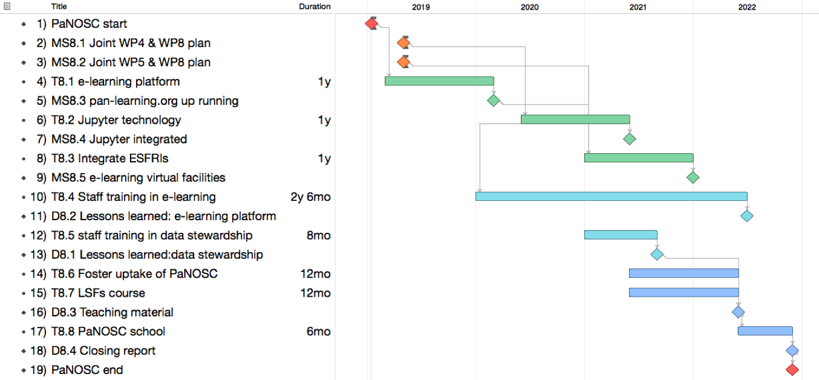

*Figure 1 Gant chart specifically for WP8*

The work package has some critical risks, dependencies, and opportunities discussed below.

**e-neutrons.org:** The technical platform for WP8 is the e-learning platform [e-neutrons.org](https://www.e-neutrons.org/), which as part of the work package will be migrated to ESS and adapted for the needs of all PaNOSC partners (incl. a new and more inclusive domain name). The platform has so far been developed by staff at Technical University of Denmark and University of Copenhagen. This key staff will be part time seconded to ESS to support the migration and further development of teaching material.

**WP4:** WP8 will integrate Jupyter technology from WP4 into the e-learning platform to enable development of tutorials. To mitigate this dependency on WP4, joint plans mapping out the dependencies on WP8 will be developed jointly with WP4. MS8.1 acts as a control point to ensure that this has indeed happened.

**WP5:** WP8 intend to leverage the developments in WP5 to enable the use of instrument simulations for teaching purposes. To mitigate this dependency on WP5, joint plans mapping out the dependencies on WP8 will be developed jointly with WP5. MS8.2 acts as a control point to ensure that this has indeed happened.

**Facility staff**: Staff at facilities are involved at two levels; 1) They should *receive* training, and 2) they should *provide* training material for the e-learning platform. The challenge is that the staff that should be addressed here are not necessarily the staff involved in PaNOSC, which makes it harder to ensure their engagement. To facilitate their engagement, two activities were planned and agreed on at the WP8 parallel session at the kick off meeting;

1. Make the e-learning platform more attractive for scientific facility staff by integrating Jupyter technology earlier than planned and in this way make it possible to create tutorials on data analysis. This should be reflected in the joint plan with WP4 (MS8.1).
2. Each representative should return to their home institution and get feedback on which teaching materials they would like to see developed for the e-learning platform. This will form the basis for the activities in Task T8.4, which will be kicked off with a joint workshop for all partners where the relevant staff will be trained in developing material for the e-learning platform. Staff at the facilities are then responsible themselves for implementing that teaching material but with assistance provided by ESS.

**Summer schools:** Summer schools are critical for success of the final Task T.8.8 in Year 4 addressing user training. An initial discussion of this took place at the parallel session and the discussion will continue at the next WP8 meetings. The WP is in this regard fortunate to have the organizer of the Hercules school involved.

**Related activities**: At the WP8 parallel session and again at the close-out session at the kick-off meeting, the opportunities for dissemination, and liaison and collaborate with other projects were discussed. CERIC agreed to investigate which related activities exist in other EOSC projects as part of WP9 in order to explore the opportunities.

## Work Package 9 Approach

The Outreach/Communication and Dissemination/Impact work package (WP) will set-up and deploy all useful and relevant tools (website, social media, print materials, articles and press releases, meetings at events, etc.) to inform and engage the project’s stakeholders on EOSC functionalities, operation and developments, and to disseminate the project’s outputs (reports, best practices’ guidelines, policies, standards, methodologies, technical and operation information, guidance documents, (video) tutorials, etc.).

CERIC-ERIC, as leader of the WP, will take care of promoting project’s activities, advancements and events, and of disseminating its outputs:

* By producing promotional and informative content for publication on and distribution through all available project’s communications channels;
* By ensuring that all press and communications officers at the partners, and therefore the management and staff at their institution, are timely informed and up to date about latest news and achievements related to the project;
* By promoting the EOSC services developed in other WPs, and the training platform developed in WP8;
* By supporting the communication and promotion of the project’s and other relevant EOSC-related events;
* By sharing and circulating information, results and updates about the project to its stakeholders.

The details of the tools and actions planned throughout the project for a proper communication and dissemination of its activities and results will be developed in the first months of the project and published before the end of month 6, in the project’s communication and dissemination strategy and plan (D9.1).

Finally, in coordination with the project’s coordinator, CERIC-ERIC will ensure that all documentation produced for communication and dissemination is available on GitHub and any other tool used for internal communications.

## PaNOSC’s Tasks, Deliverables and Milestones

The following two images show the planned tasks, deliverables and milestones in PaNOSC.

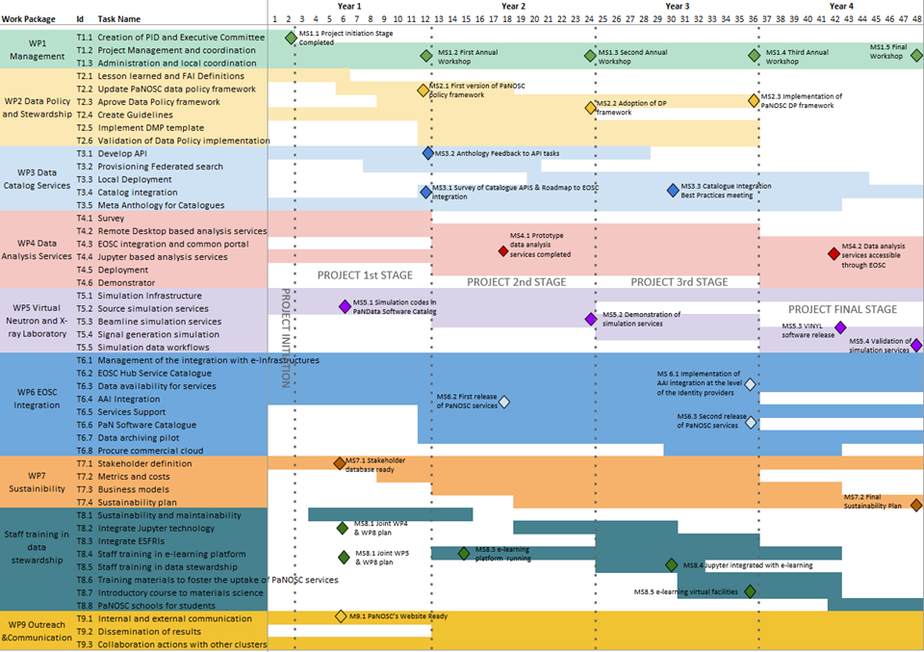

*Figure 2 PaNOSC's tasks and major milestones*

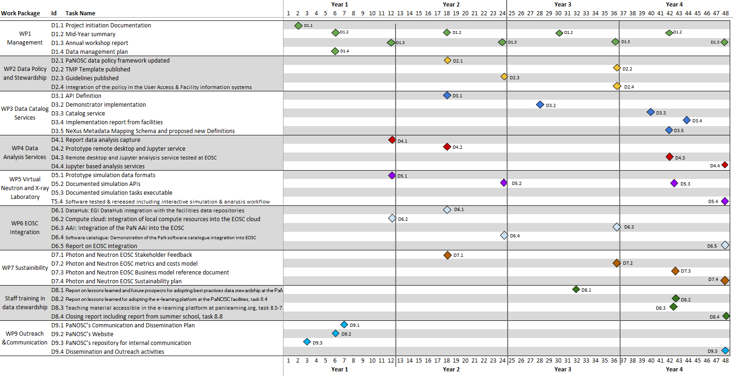

*Figure 3 PaNOSC's deliverables*

# Team Structure

The organisational structure for the project will comprise the following bodies.

- **Executive Board** as the ultimate decision-making body of PaNOSC.

* **Project Management Committee** as the supervisory body for the execution of the Project which shall report to and be accountable to the Executive Board.

Each Work Package will have a leader in charge of coordinating and delivering the work agreed in the PaNOSC proposal, feeding back status information to the Project Management Committee. His/her responsibilities will therefore include:

* Coordination, assignment, and review of WP issues as per tasks, deliverables, and milestones
* Coordination of reporting for deliverables and milestones
* Planning of WP sessions for the annual meetings
* Organization of regular (online) meetings among involved partners and with connected WP leaders

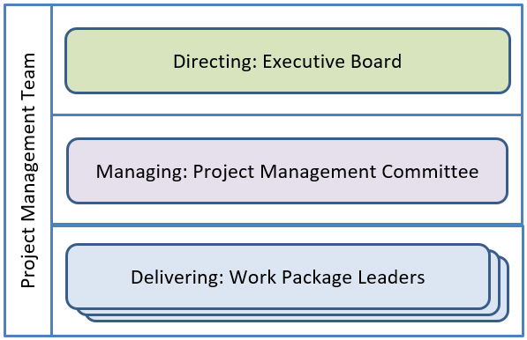

*Figure 4 Project Team functions*

There will be as well the Project Manager and the Project Support Team assisting the Coordinator.

A Consortium Agreement will be put in place during the first year of execution of PaNOSC, including further detail about:

1. General structure of the governing bodies
2. Representation in meetings
3. Preparation and organisation of meetings
4. Voting rules and quorum
5. Notes of meetings

Each member partner participating in PaNOSC (ESRF, ILL, XFEL.EU, ESS, ELI-DC, CERIC-ERIC and EGI) will appoint a member for the Executive Board and Project Management Committee, being present at all of the meetings of these two bodies and appoint a substitute or a proxy when required.

A Non-Executive Advisory Board will be made up of observers, which will have a special role in the project. They represent the national RIs in the PaN community, PRACE host members, and other stakeholders. They were invited in the beginning of the project at a kick-off meeting (15th and 16th January 2019) to ensure their requirements for applying the outcomes of PaNOSC are met. The Observers will be consulted all along the project to give feedback and input.

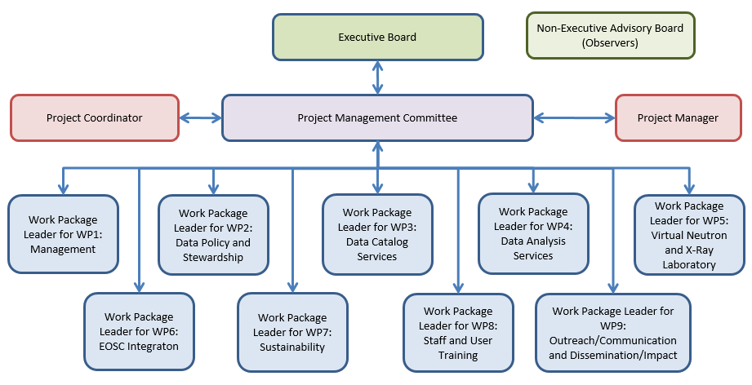

*Figure 5 Project Management team*

The list of members of the Executive Board, Project Management Committee and Work Package Leaders will be available to the project team in GitHub and in the Appendix II.

During the first Executive Board meeting a Chairperson will be elected by at least four-sevenths (4/7) of its members. The Executive board elected Rudolf Dimper (ESRF) as the first EB chair for 2019.

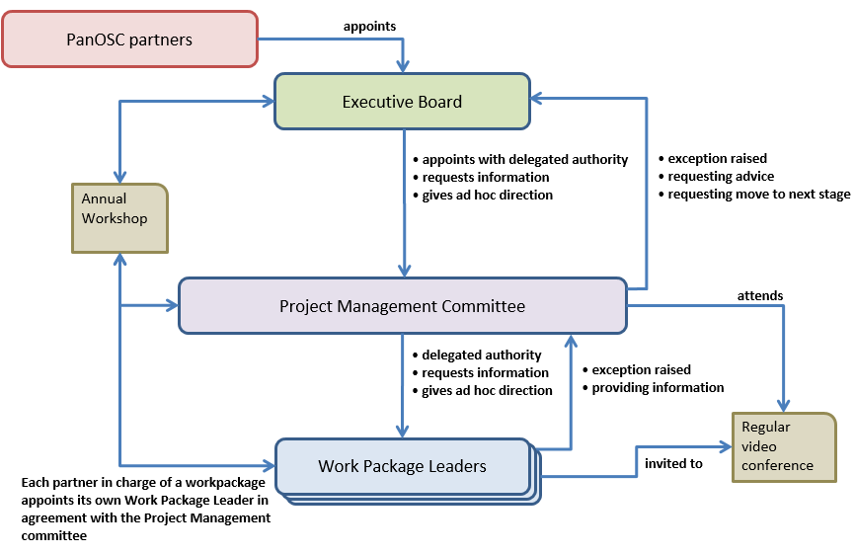

*Figure 6 Project team interactions*

# Communication Management Strategy

## Internal Communication

In order to ensure that information flows between the different work packages, *Work Package Leaders*, *Project Management Committee* and the *Executive Board* we aim to hold regular meetings:

* Monthly video conferences chaired by the *Project Manager* and attended by Project Management Committee members with Work Package leaders invited to give an update of their area.
* Annual Workshop attended by the Executive Board members, Project Management Committee, and Work Package Leaders. Observers and key contributors to work packages will be invited to attend as well.

Summary notes from the meetings and reports will be available to project members via GitHub (<https://github.com/panosc-eu>).

In addition to GitHub, which is the main partners’ archive and source of deliverables and working documents (e.g., policies, white papers, reports, minutes, etc.) the partnership will rely on public Cloud services such as Google Drive, to jointly work on files and documents with no confidentiality restrictions. Where maximum confidentiality is called for, documents will be exchanged via direct e-mail and through the online Cloud-based repository dedicated solely to the project hosted on partners’ own servers (D9.3).

On top of these meetings, more regular meetings will be scheduled as required, to ensure that information flows between the governing bodies and work package leaders and between different work packages.

Each work package leader will be in charge of organising the communication within its work package contributors and stakeholders, with regular meetings (via videoconference) encouraged.

PaNOSC will use dedicated mailing lists for different audiences:

* Executive Board mailing list (Executive Board members and Coordinator): [executive@panosc.eu](mailto:executive@panosc.eu)
* Project Management Committee mailing list (Project Management Committee members, Project Coordinator, Project Manager and Work Package leaders): [management@panosc.eu](mailto:management@panosc.eu)
* Work Package lists (one mailing list per work package with membership administered by the work package leader): [wp1@panosc.eu](mailto:wp1@panosc.eu) … [wp9@panosc.eu](mailto:wp9@panosc.eu)
* Information list (for observers and other stakeholders interested in the project): [info@panosc.eu](mailto:info@panosc.eu)
* Mailing list to address administrative issues/questions: [contact@panosc.eu](mailto:contact@panosc.eu)

## External Communication

External Communication will fall within the work package 9: Outreach/Communication and Dissemination/Impact and will be defined in detail in the deliverable D9.1 PaNOSC’s Communication and Dissemination Plan. Its goal is to engage all project stakeholders in further developing and integrating services into the EOSC, and to ensure the dissemination and foster the exploitation of the project outputs and results by all available means.

The external stakeholders identified as target groups for the project’s communication and dissemination activities are:

* *European PaN sources*
* *PaN user community*
* *Community of research infrastructures from other clusters*
* *e-infrastructures*
* *Community of current and prospective ERICs*
* *Researchers at large in both academia and industry*
* *Other contributors to the EOSC*
* *European Commission, national authorities and funding agencies, and policy makers*

Actions taken to pass information to and to interact with stakeholders will have the following forms:

1. Public project updates via the project’s and its partners’ websites, newsletters and social media posts, as well as articles and/or press releases about key PaNOSC’s events and achievements.
2. Interaction with multiple stakeholders at the project partners’ user meetings, at scientific and industrial workshops and conferences Europe-wide, at the ERIC Forum meetings, at the ICRI conferences and at the EU presidency’s events.
3. Interaction with contact points of the National Ministries:

* At the partners’ governing bodies’ meetings;
* At events organized by the Ministries;
* By standard contact points of government grant agencies in countries where partners are present.

1. Interaction with other clusters for the coordination and co-development of services.
2. Consult and discuss with the Observers and other members in the PaNdata community.

EXTERNAL COMMUNICATION TOOLS AND CHANNELS:

PaNOSC foresees the deployment of a wide set of tools for external communication:

* The PaNOSC website: <http://www.panosc.eu> will be released in its full version at the end of month 6
* Social media: the @Panosc_eu Twitter account will be updated weekly to set-up and engage the research community around the world, as well as representatives from national and European institutions, ERICs and research infrastructures, and other EOSC stakeholders. Project’s partners will also share and disseminate published content by sharing it through their own social media channels.  
  Moreover, video tutorials generated throughout the project will be available from the e-learning platform developed in WP8, and on YouTube.
* Articles and press releases will be published on the project’s and its partners’ websites, as well as distributed to the media when appropriate, to promote the project’s activities and keep its stakeholders updated about latest news, events and achievements.
* Events such as workshops, seminars, conferences, meetings, etc., will be organized and attended to maximize the impact of every single WP and of the overall project’s results.
* Guidelines with best practices and tutorials on the use of the EOSC services will be made available in the project’s website and in the e-learning platform (to appear on www.pan-learning.eu), which will be active and accessible even after the project ends.

A detailed Communication & Dissemination strategy and plan will be developed in WP9 in the first six months of the project. It will include measures that will be taken towards each target group, in order to maximise the impact of the project.

The events and meetings listed below have been identified as efficient to target project stakeholders, and to collect comments and advice for a further fine-tuning of the policies, standards, plans and services developed. The list is not supposed to be comprehensive. Channels created in the frame of PaNOSC are those written in italic.

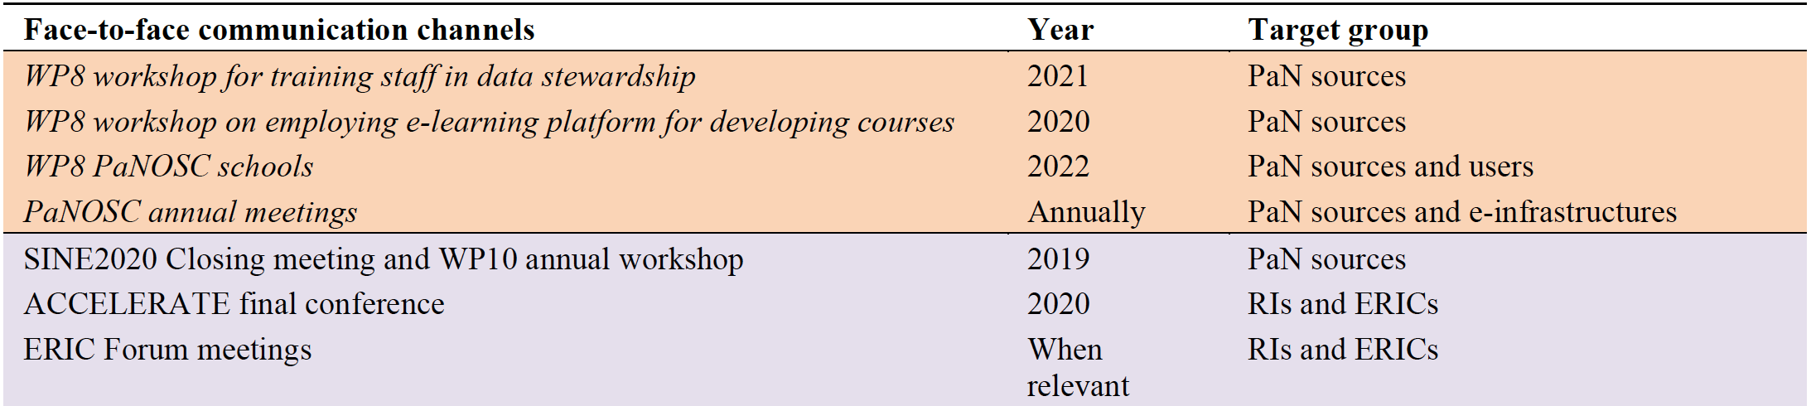

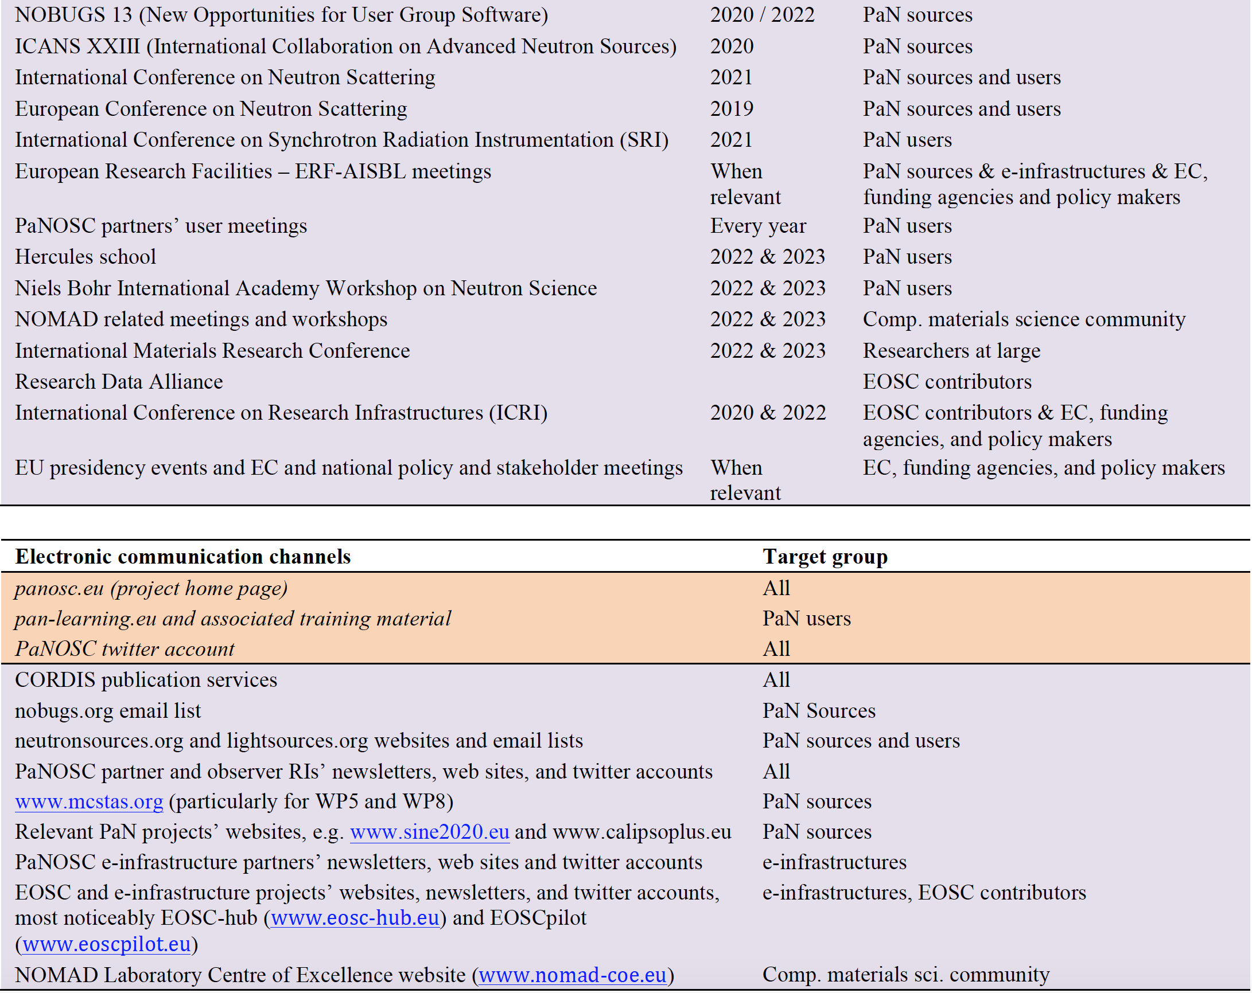

# Risk Management Strategy

All risks initially identified are documented in the risk register hosted in GitHub. Then a risk owner will be assigned (in charge of monitoring the risk, implementing mitigation strategies and responses).

The risk register will be available to the project team, with risks reviewed regularly (the more important ones being reviewed more frequently).

An initial assessment of a risk will be made based on its probability (likelihood of materialising) and impact (how it will affect the project).

At the time of writing (January 2019) risks have not been reassessed or assigned an owner (however this was highlighted as a pending task during the kick-off meeting), therefore risks have not changed since the proposal was submitted.

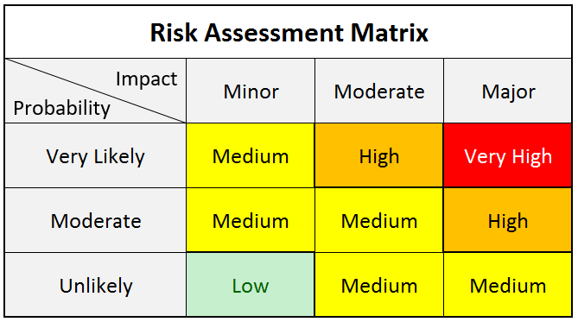

*Figure 7 Risk assessment matrix*

High and very high risks will be reviewed during each Project Management Committee meeting (or monthly if several meetings take place within a month).

All risks will be reviewed before each Executive Board meeting.

# Quality Management Strategy

## Quality Reviews

In order to ensure the quality of all work done within PaNOSC we will put in place quality reviews. These reviews will ensure that deliverables and internal products will be reviewed by a different team/member of staff than the one that created it, in order to provide suggestions for improvement and corrections.

# Configuration Management Strategy

In order to ensure that we do keep all information, control versions of documents and we share them effectively we will use GitHub. GitHub is a version control hosting service for Git that includes also access control and wikis widely used in the open source community.

## Issue Log

PaNOSC will use an Issue Log in order to keep track of all issues (relevant events not planned that require actions, concerns, queries, requests for a change, suggestions, off-specification, etc.) related to the project.

The Issue Log will be available in GitHub to the project team, with the issues being reviewed regularly and member of staff assigned to deal with the issue. A snapshot of the current issues can be found in the Annex III.

## Management Key Performance Indicators

PaNOSC will introduce by the end of the first year certain Key Performance Indicators (KPI) to easily review the status of the project. These KPIs will be focusing on the following information:

* Deliverables and progress
* Project outputs adoption by users
* Risks
* Issues
* Budget and expenses

The KPIs will be available to the Executive Board and Project Management Committee.

## Work Package Key Performance Indicators

PaNOSC will introduce by the end of the first year certain KPIs to easily review the status of each work package. These KPIs will be decided by the work package leader and the Project Management Committee.

# Appendix I: Work Package descriptions

|  |  |  |  |  |  |  |
| --- | --- | --- | --- | --- | --- | --- |
| Work Package 1: Management | | | | | | |
| **Lead beneficiary** | **ESRF** | | | | | |
| **Participant number** | 1 | 2 | 3 | 4 | 5 | 6 |
| **Short name of participant** | **ESRF** | ILL | XFEL.EU | ESS | ELI | CERIC-ERIC |
| **Person months per participant** | 49 | 3 | 3 | 3 | 3 | 3 |
| **Start month** | 1 | | **End month** | | 48 | |

|  |
| --- |
| **Objectives**  Manage and coordinate the project to ensure that the objectives are delivered on time. Organise regular follow-up meetings and annual workshops to ensure progress and results are communicated between participants, observers and the community at large. Interact with and follow-up all other work packages while managing change and risk. |

|  |
| --- |
| **Description of work**  **Task 1.1 Creation of Project Initiation Documentation (M1-M2)**, appointment of Executive Committee and selection of the tools to be used for project management.  *Leader: ESRF Contributors: ILL, XFEL.EU, ESS, ELI and CERIC-ERIC*  **Task 1.2. Project management and coordination (M1-M48)**: kick-off meeting, monthly video conference and an annual conference will take place. Submission of regular reports, financial statements and deliverables as defined by the contract, including all liaison with the EC. Change, progress, scheduling, communication and risk will be managed as part of this task as well as monitoring of job advertisements across project to improve gender balance  *Leader: ESRF Contributors: ILL, XFEL.EU, ESS, ELI and CERIC-ERIC*  **Task 1.3. Administration (M1-M48):** capturing and reviewing all actual information about actual costs (financial and human resources efforts) and comparing it with the planned forecasts.  *Leader: ESRF Contributors: ILL, XFEL.EU, ESS, ELI and CERIC-ERIC* |

|  |
| --- |
| **Deliverables**  **Deliverable 1.1** Project Initiation Documentation (M2, R, PU, ESRF)  This set of documentation will include an executive summary for the project, its governance (including rules to appoint Executive Committee members), scope, organisation, risk management strategy, communication strategy, list of stakeholders, the list of executive committee members, executive committee appointment rules and initial set of risks and issues identified.  **Deliverable 1.2** Mid-year summaries of regular video conferences (M6, M18, M30, M42, R, PU, ESRF) This will consist of a summary of the regular video conferences that will take place as part of *Task 1.2 Project management and coordination* and it will include news from the partners about their progress and a snapshot of the current health of the project.  **Deliverable 1.3** Report of annual workshop (M12, M24, M36, M48, R, PU, ESRF)  These reports will focus on the activities of the annual workshop, status of the project, summary of progress achieved during the year, residual risks, main changes to the project and a report from the Executive Committee.  **Deliverable 1.4** Data Management Plan reviewed and agreed to by partners (M6, R, PU, ESRF)  Data Management Plan following H2020 guidelines, reviewed and agreed to by all partners. |

|  |  |  |  |  |  |  |
| --- | --- | --- | --- | --- | --- | --- |
| Work package 2: Data Policy and Stewardship | | | | | | |
| **Lead beneficiary** | **ESRF** | | | | | |
| **Participant number** | 1 | 2 | 3 | 4 | 5 | 6 |
| **Short name of participant** | **ESRF** | ILL | XFEL.EU | ESS | ELI | CERIC-ERIC |
| **Person months per participant:** | 17 | 10 | 3 | 14 | 20 | 12 |
| **Start month** | 1 | | **End month** | | 36 | |

|  |
| --- |
| **Objectives**  The overall goal of the work package is to enable facilities to ensure their data policies honor the FAIR principles in the way they curate data. Currently some of the participating facilities have defined data policies (ILL, ESRF, XFEL.EU and ESS) others still have to define and apply a data policy (ELI and CERIC-ERIC). All members have committed to adopting an Open Data data policy as part of the PaNOSC proposal. The existing policies are based on the PaNdata policy 10 years ago, and have provisions for Open Data. Nowadays, the FAIR data principles[1] more clearly define the concepts of Open Data. The goal is therefore to update the current policies while respecting the specific needs of the PaN community, to better align with current understanding of FAIR principles. PaNOSC will foster links to experts in applying FAIR principles to research data like OpenAIRE and Force11 to validate the data policies. Based on the current barriers of adopting FAIR principles, the following objectives have been identified:   1. Definition and harmonisation of PaN specific data policies and management of Intellectual Property Rights (IPRs) and ethical issues; addressing legislative and interoperability issues which affect data handling across geographical and discipline borders specific to the PaN community. 2. Definition and adoption of common open standards for interoperability. Registering with and citing of these standards by standards bodies and publishers. 3. Stewardship of data handled by the involved research infrastructures according to the FAIR principles. Citing of PaN data repositories and data descriptors by publishers e.g. <https://www.nature.com/sdata/policies/repositories> 4. Produce guidelines for best practices based on experience of those PaN partners who already have Open Data policies since a few years now to help partners adopting Open Data data policies correctly from the start. The guidelines will be shared with the rest of the PaN community. Guidelines for dealing with typical PaN issues like huge data sets will be dealt with by exploring data reduction and compression schemes which reduce the burden on the data infrastructure. |

|  |
| --- |
| **Description of work**    **Task 2.1: Lesson learned and FAIR Definitions (M1-M6)** *Leader: CERIC-ERIC. Contributors: ESRF, ILL, XFEL.EU, ESS, ELI*  Compile lessons learned from previous policies of the partners and other members of the PaN community who have experience putting data policies in place. To identify existing barriers for making the community accept FAIR principles, we will collect the existing experience and give recommendation for how to overcome such barriers. Consult with expert organisations like Force11 and OpenAIRE to understand latest research and best practices in applying FAIR principles to data.  **Task 2.2: Updated PaNOSC Data Policy framework (M6-M18)** *Leader: ESS. Contributors: ESRF, ILL, XFEL.EU, ESS, ELI*  Based on the existing PaNData policy[2] create a new PaN data policy framework that all facility specific data policies should adhere to. Ensure that the data policy framework is aligned with EOSC activities on data policy harmonization. The aim of the policy is to ensure that FAIR principles are applied as broadly as possible.  **Task 2.3: Approve Data Policy framework (M9-M36)** *Leader: CERIC-ERIC. Contributors: ESRF, ILL, XFEL.EU, ESS, ELI*  Participating facilities will publish and apply or align their current data policies with the new policy based on the common key principles defined in task 2.2 for their facility or amend their existing policy to be consistent with the FAIR principles.  **Task 2.4: Create Guidelines (M1-M24)** *Leader: ESRF. Contributors: ESS, ELI, XFEL.EU,CERIC-ERIC*  Creating Guidelines for DOIs, long term archiving, and FAIR data (legal aspects) Support best practice by e.g. formulating a click through license agreement to be accepted when submitting proposal, creating or downloading data covered by policy. Create Guidelines for handling GDPR and other legal aspects of federating data. To ensure legal aspects will not be a barrier for adoption of FAIR data, clear guidelines are needed. Part of this will be to establish a common set of definitions for policies, using and publishing data.  **Task 2.5: Implement DMP template (M12-M36)** *Leader*: *ESS*. *Contributors: ILL, CERIC-ERIC*  Define and implement a template for DMPs for experiments performed at the PaNOSC research infrastructures. Have support for automatic filling out of the template based on existing information about experiment (e.g. proposal text).  **Task 2.6: Validation of Data Policy implementation (M12-M36)** *Leader: CERIC-ERIC. Contributors: ELI*  We will follow up with multi facility partners (CERIC-ERIC and ELI) and other partners who already have a data policy to track and document the progress on adopting or adapting their existing policies to the PaNOSC data policy framework. |

|  |
| --- |
| **Deliverables**    **Deliverable 2.1** PaNOSC data policy framework updated (M18, R, PU, ESRF)  **Deliverable 2.2** DMP Template for facility users published (M36, R, PU, ESS)  **Deliverable 2.3** Guidelines on best practices implementing the PaNOSC data policy framework published. (M24, R, PU, ESRF)  **Deliverable 2.4** Integration of the policy in the User Access and facility information systems (M36, R, DEC, CERIC) |

|  |  |  |  |  |  |  |
| --- | --- | --- | --- | --- | --- | --- |
| Work package 3: Data Catalog Services | | | | | | |
| **Lead beneficiary** | **ESS** | | | | | |
| **Participant number** | 1 | 2 | 3 | 4 | 5 | 6 |
| **Short name of participant** | ESRF | ILL | XFEL.EU | **ESS** | ELI | CERIC-ERIC |
| **Person months per participant:** | 25 | 21 | 36 | 43 | 78 | 88 |
| **Start month** | 1 | | **End month** | | 48 | |

|  |
| --- |
| **Objectives**  The overall goal of the work package is to provide an EOSC service that allow for users to seamlessly and easily access data from the diverse set of catalogs at the existing facilities. The situation today is that there is a plethora of different catalog services that each allow for access to data in slightly different ways. Some solutions are used in more than one place (e.g. ICAT) but quite commonly with local adaptations, and not allowing for federation of other similar catalogues. The work package will not supplant the existing services, but rather define a unified API and enable the existing and future services to be used by EOSC through the API. The API, test harness, demonstrator implementation as well as lessons learned from deploying it will be made publicly available, making it easy for facilities outside the PaNOSC to adapt and have their data exposed in the EOSC. The work package objectives in more detail are:   * Provide a federated data catalog service across the Photon and Neutron community, compatible with OpenAIRE. * Definition of standard metadata for scientific domains at the partner facilities to access to data beyond the generic search features of OpenAIRE, enabling new and interdisciplinary research leading to new insights and innovation for the society at large. * Facilitate access of researchers across all scientific disciplines to the broadest possible set of data and to other resources needed for data driven science to flourish. * Integrate the data catalog with the existing data sources (e.g. experimental stations). This includes the integration of the data production facilities with the catalogue service.   Datasets in the public domain (after an embargo period) shall be findable to the interested public and wider scientific community at large, possibly after registration to enforce policy compliance (expected input from WP2). During the embargo period for a dataset access may be restricted to the original proposer or facility. |

|  |
| --- |
| **Description of work**  The work package will create an API that existing catalog solutions can adopt to allow for seamless integration into EOSC via OpenAIRE. The API description will be accompanied by a test suite that can test a given implementation for compliance. To further illustrate the intended behavior, a demonstrator implementation will be developed. Furthermore a web service will be deployed that will allow for search across facilities exposing the API. Finally, all the participating facilities will expose their data through the API according to their data policies and the joint data policy framework developed in WP2.  **Task 3.1: Develop API (M1-M28)** *Leader: ESS. Contributors: ESRF, ILL, XFEL.EU, ELI, CERIC-ERIC*  Define an API to be used in the Photon and Neutron community that will allow for FAIR exposure of the data at the individual institutions through a catalogue service. The API will allow federation, and exposure of metadata relevant for the area, in a way that will enable search and facilitate access of researchers across scientific disciplines. Existing APIs (e.g OAI-PMH) and communities (e.g. openarchives.org, Dublin Core Metadata Initiative (DCMI), OpenAIRE) will be taken into account. The API will enable domain specific search extensions aware of the metadata definitions and usage at photon and neutron facilities.  In order to test any implementation at facilities for compliance, a set of API tests will be developed. The test harness will be executable against a given site catalogue service and result in a report stating the status towards compliance.  An implementation, based on an existing solution is developed and deployed at a facility to show the feasibility of the approach. The implementation is to be fully compliant with the API, but not necessary performant for very large catalogues.  **Task 3.2: Provisioning Federated Search (M8-M20)** *Leader: ELI. Contributors: ESS, CERIC-ERIC*  This task will link the PaNOSC beneficiaries’ data catalogs to the EOSC hub. The EOSC hub will provide the API needed to share and search metadata. In the absence of a definition following the OpenAIRE DOI equivalent scheme should yield sufficiently wide exposure. A web service demonstrator will be provided that allows searching all PaNOSC partner sites for available datasets using the common metadata API. The demonstrator will showcase how access to the catalogue will provide identifiers that will allow the found data to be accessed and used for analysis. Once the demonstrator is working the next step will be to work with EOSC hub to provide a production ready service to be provided as part of EOSC.  **Task 3.3: Local Deployment (M20-M44)** *Leader: ESS. Contributors: ESRF, ILL, XFEL.EU, ELI, CERIC*  The participants will implement the mandatory part of the API for their local data repository. This includes effort required to ensure that all facilities metadata is compliant with the standards from WP2. The implementation is expected to happen through extending the existing catalogue services at the partner sites with the API or by an equivalent solution.  **Task 3.4: Catalog integration (M12-M48)** *Leader: ELI. Contributors: CERIC-ERIC, ILL, XFEL.EU, ESRF, ELI*  Integration of data production facilities with the data catalog which is especially important for heterogeneous and distributed facilities. This task will document best practices and support heterogenous and distributed facilities getting their workflow to support cataloging data.  **Task 3.5: Meta Anthology for Catalogues (M1-M42)** *Leader: ESS. Contributors: ESRF, ILL, XFEL.EU, ELI, CERIC-ERIC*  Extend NeXus metadata standards to enhance interoperability. In order to operate on their own data across facilities or explore relevant foreign datasets in the public domain, searches on the scientific metadata need to yield the correct results. For large parts of the communities NeXus is the most commonly used file format. It is the only one with an ambition the extend into all relevant scientific fields, for both raw and derived data. Building search terms and keywords from the NeXus dictionary, would make use of the community buy in and expertise that went into this standard. However, NeXus is based on a hierarchical backend, tree like storage, making use of parent-child relationships, that do not straightforwardly map into usually flat search terms.  In addition developing a standard mapping for existing NeXus definitions, in this task we can add missing definitions for raw data, as well as for processed derived data. With the results to be proposed to the NeXus committee for community adoption. |

|  |
| --- |
| **Deliverables**  **Deliverable 3.1** API definition (M18, R, PU, ESS)  **Deliverable 3.2** Demonstrator implementation (M28, Other, PU, ESS)  **Deliverable 3.3** Catalog service (M40, DEC, PU, ESS)  **Deliverable 3.4** Implementation Report from Facilities (M44, R, PU, ESS)  **Deliverable 3.5** NeXus Metadata Mapping Schema and Proposed New Definitions (M42, R, PU, ESS) |

|  |  |  |  |  |  |  |
| --- | --- | --- | --- | --- | --- | --- |
| Work package 4: Data Analysis Services | | | | | | |
| **Lead beneficiary** | **XFEL.EU** | | | | | |
| **Participant number** | 1 | 2 | 3 | 4 | 5 | 6 |
| **Short name of participant** | ESRF | ILL | **XFEL.EU** | ESS | ELI | CERIC |
| **Person months per participant:** | 36 | 71 | 60 | 32 | 50 | 60 |
| **Start month** | 1 | | **End month** | | 48 | |

|  |
| --- |
| **Objectives**  Data analysis is the process of extracting meaning from recorded data, and thus enables the transition from measurements to insight and new science. In the context of photon and neutron science, this is an essential and non-trivial process and can extend over weeks and months for a single experiment. To make (so-called) raw data usable and re-usable for research, it is critical that we provide such data analysis services together with the data. The size of the activity planned here is commensurate with the importance of it to enable new science from existing data. We expect some of the outputs will benefit science beyond photon and neutron facilities and users.  The objective of this work package is to make such data analysis services available through cloud hosted services and on the EOSC. In particular, this means that it must be possible to choose, control and execute analysis services remotely. Ideally the user interface for local and remote execution is identical or at least similar. In the context of the FAIR principles, a complementary objective is to support traceability, persistent identification, and reproducibility of the data analysis process from raw data to publication data. |

|  |
| --- |
| **Description of work**  In this work package, we make analysis tools and services available for remote execution in the cloud.  We have identified two technologies that we plan to explore as priorities (see Section 1.3.b.1) but will in addition carry out a review of other possibilities at the beginning of the project, and at later points to stay connected to leading edge developments and opportunities. The first technology is based on browser driven remote desktop execution (Section 1.3.b.3), i.e. the provision of virtual machines that are tailored for particular data analysis tasks and which can be controlled remotely through a web browser which hosts a graphical desktop interface. This is the most generic approach as any application currently used can be hosted in the virtual machine and the ‘usual’ interface (be it graphical or command line) can be displayed remotely in the browser (T4.2). We will deploy this to project partners (T4.3) and the EOSC in WP6.  The second technology is to combine the Jupyter Notebook[3] with bundled execution environments through containers (T4.4) as described in Section 1.3.b.2. This has advantages of being designed for remote access, allowing users to access the service with the webbrowser of their choice on their machine, and allowing much better support of the FAIR principles through intrinsic reproducibility. While we predict the importance of this approach to grow, the Notebook hosted data analysis service is not usable for all data analysis requirements. This will be deployed to all partners (T4.5) and to the EOSC in WP6.  These services have also different maturity levels whether they are in pilot or production phase, ranging from TRL 7 to 9.  Currently most of the analysis services are run on the IT infrastructure of each facility, and the computing hardware is thus typically physically close to the data storage hardware. Some of the (derived) data sets are small (~GB) and can be moved through the Internet to other locations, but for some data sets the effort of moving the data is substantial (~TB), and can be prohibitive on short timescales (hours). In principle, we have the options to either carry out the computation where the data is, or move the data to the compute resource. Which model is feasible will depend on a complex set of factors including available compute and data resources at facilities and the EOSC, technology for moving computation and data, and willingness of users to wait for data migration. This is an important issue affecting most tasks in this work package.  The issues with reproducible and remote data analysis, that are advanced in this work package, are not unique to photon and neutron science but shared by many areas of data-driven science and computational science. Furthermore, the technologies we will bring to the EOSC – such as the tools from the Jupyter ecosystem – have much wider applicability. As we will contribute to making this tools more robust and flexible, we will create value for many more researches and domains beyond photon and neutron science.  **Task 4.1** Survey data analysis requirements and solutions at the partner sites, and horizon scan other emerging tools and technologies (months 1 - 12), *Leader: ILL. Contributors: ESRF, XFEL.EU, ESS, ELI, CERIC-ERIC*  We will create a survey for each partner aiming to collect the different solutions, workflow and technology already offered for data analysis services. This includes raw data access, analysis software availability and preservation of results.  We will analyse the survey results and identify best practices and tools that can be used more widely. Feasibility analysis will take into account technology, cost and security for the partners and the EOSC integration. We will identify particular pilot data analysis services that will be made available first through EOSC, and which will be realised in Tasks 4.2 to 4.5.  We will review developments that affect remote provision of analysis services (such as workflow and compute environment management tools, tool sets for reproducible analysis etc). If deemed appropriate, we may amend later tasks in this work package accordingly to benefit from these emerging technologies.  **Task 4.2** Remote desktop based analysis services (1-36 month). *Leader: ILL. Contributors: ESS, CERIC*  Using remote desktop and cloud technology we can offer a remote data analysis experience that appears as if the display of a local computer is available remotely. This is achieved by providing a graphical desktop of data analysis computing machines accessible via the users web browser. In the background, we use virtual machines, hosted at the facility and located close to the data archive or in the cloud (providing that the data have been transferred to the same location), to provide the analysis software, storage and computing capacity that is tailored to each use case. These services are currently in their pilot phase at the ILL. Feedback from the pilot We will improve the usability, features and support tools in preparation of a larger user audience based on the feedback received from the pilot. This initially concerns the integration of screen sharing/broadcasting capabilities, screencasts and communication tools (video conference, chat, discussion boards). Other users’ requests received during the remaining course of the pilot may also be taken into depending on the resources still available. Software distribution repository The photon and neutron facilities cover very diverse scientific fields and therefore the ecosystem of analysis software is extremely large (more than 100+ referenced software).  Offering virtual machines with all of the analysis software locally installed has proved to be unmanageable in terms of maintenance, software update and consequently security.  To solve this issue, the analysis software can be offered on demand instead of being installed locally on a virtual machine. This will be achieved by offering a software distribution repository for the PaN community based on the CERNVMFS technology. In this task we are going to setup a repository server, install a pre-selection of analysis software for distribution and then integrate the repository client inside the virtual machine. We also need to organise the workflow and responsibility of distributing the selection of software to the virtual machines. Reference implementation documentation Provide technical documentation to allow all partners and others to implement the Remote Desktop service for their facility. This will include all the required components and interfaces to allow each partner to deploy an installation tailored to specific requirements of their facility. This will take into account the fact that each facility has different user registration, proposal management and data archive systems.  **Task 4.3** EOSC integration and common portal for remote data analysis services (M13-48), *Leader: ILL. Contributors: all*  We will provide a service that will allow a user to remotely analyse their data from any facility via a common portal. Federated authentication and cross facility data transfer will be required for the common portal to reach its full potential. These requirements will be addressed in WP6 Task 6.3 and 6.4. In this task we will implement a facility connector for the remote desktop services and adapt these services for the EOSC AAI and data transfer mechanisms. EOSC Authentication and Authorization Infrastructure In this task we will implement the technical solutions chosen in WP6 to authenticate the users in the different layers of the portal architecture (the portal itself, the data access and the machines). This authentication should allow the different providers to grant the proper authorization and to implement service usage accounting. We will review the security of the system to identify risks and necessary security measures. Data sharing We will modify the compute services to benefit of the work in WP6 concerning the movement of data. By integrating the data transfer solution we will allow users to transparently work on data, irrespective of its location, and perform data analysis. Common platform We will extend the single site remote desktop portal for the selection of the compute and data providers. Each participating facility will implement a connector that allows the common portal access to their compute infrastructure and manage the transfer of data. A user will be able to select any facility and start remotely analysing their data via a single interface. This common platform, based on existing solutions, should also provide the possibility of directly archiving and sharing results after a user has completed their data analysis using the services provided.  **Task 4.4** Jupyter ecosystem based data analysis services (M1-48) *Leader: XFEL.EU. Contributors: ESRF, ESS, ELI, CERIC-ERIC, ILL*  The Jupyter Notebook (Section 1.3.b.2) is an executable document, hosted in a web browser. The notebook is composed of a sequence of input cells, each of which can contain text or code. Code input cells are numbered and can produce textual or multimedia output. These outputs are displayed inside a web browser that is connected to a computational backend. This backend can be the same machine on which the notebook is displayed in the browser, or a remote server, making this technology immediately usable for remote and cloud access while providing exactly the same interface.  Throughout this task we will work with scientists at our facilities to ensure practical value and ease of use from the users’ perspective. User groups across the partner facilities have already started to use Notebooks where currently possible. We will also work with the Jupyter team and contribute required modifications to the code base back to the community in order to avoid duplication of code and effort, to make the code base of our services as sustainable as possible, and to contribute towards better data analysis beyond neutron and photon facilities and users. Local use of Jupyter Notebook based data analysis services Following from Task 4.1 we will prioritise existing data analysis services and make them available through the notebook, deploy this locally at our facilities, share experiences across partners, and gather feedback from users. The complexity varies: data analysis tools and libraries that can be scripted (through any of the Notebook supported languages, including Python and bash) are relatively easy to integrate, while for some others we may have to provide such interfaces. Amongst other packages, we will port some of the functionality of the Scientific Library for eXperimentalists (silx - <http://www.silx.org>) data reduction and graphical library to the Jupyter Notebook, focussing on high priority items that are not already available through plotting tools and Jupyter Widgets. Silx is the base platform used by the ESRF to develop data reduction and analysis applications for data from synchrotron sources. It is used by at least 5 flagship applications for spectroscopy, diffraction, and ray-tracing developed by the ESRF, ELETTRA and MAXIV, and these applications are widely used in the synchrotron community. JupyterHub for multi-user remote data analysis In this task, we will adapt and use the JupyterHub project for data analysis service provision, that can be used remotely or locally. The JupyterHub software provides a multi-user server to host multiple instances of single-user Jupyter notebook servers, to offer data analysis services remotely. The notebook servers run in separate containers, and we need to allow users to select appropriate containers for the desired analysis chain, and will have to create the containers. We will have to make the existing deployment more robust and flexible and provide a near-automatic deployment of the system on a variety of servers (at least for involved facilities and EOSC), linking the installation to appropriate authentication and authorisation and corresponding visibility of data to analyse and user specific persistent storage. The JupyterHub service has to be integrated into the orchestration of available computing resources, and needs monitoring of resources used and required. We need to extend mechanisms that allow to upload and download data through the Jupyter interface, including making use of the data catalog and its API developed in WP 3. Binder for data analysis and FAIR principles In this task, we explore and exploit solutions to bundle the execution environment with notebooks.  We will make use of the binder project (<https://mybinder.org>) to support reproducible flexible definition and selection of compute environments, in which data analysis procedures - that are coordinated through Jupyter Notebooks - can be carried out. This supports realisation of the FAIR principle as for any derived data computed, we have recorded all computation steps (in the Notebook) and we have recorded the compute environment (through the container). There are at least two canonical places for notebooks and analysis environments to be stored: (i) with the raw data as part of the metadata, and (ii) with results obtained from some data set. We need to develop guidelines and solutions where resulting notebooks are stored, considering social and technical aspects, with links to WPs 2 and 3.  Because of the lightweight nature of the containers, we expect that we can use this model to take the computation environment to the data if required. For example if a user needs to analyse a data set that is hosted by the ESRF synchrotron facilities and the data set is so large that it cannot be easily moved, we can instead relocate the computation to take place at the ESRF: we need to move the relevant container and the notebook that contains the analysis recipe to the ESRF. Another use case for moving notebook and container – which is suitable for analysis on small data sets – is to run the execution of the notebook in the container on the user’s Desktop. Towards reproducible publications As Jupyter notebooks can be saved, re-loaded and given the data and required compute environment (Task 4.4.2) also be re-executed, they help significantly in moving towards reproducible data analysis. The data science community in academia and enterprise has embraced the notebook as an executable document describing and documenting reproducible data analysis and as a high productivity tool. Beyond reproducibility, researchers can also easily extend a given reproducible analysis and thus build on existing research outputs without having to re-create the already published analysis as the first step.  In an ideal world, researchers would publish a scientific publication together with a (computer executable) script, a reference to the original data, and the computation environment in which the original data has been processed into the numbers and figures used in the publication. This would provide full reproducibility of the published results, and encourage other researchers to further exploit the data (currently researchers spent significant amounts of time to reproduce the earlier findings before embarking on new work). In this task, we extend the notebook to provide important functionality: if the code segments of the notebook could be hidden where desired, it would be possible to create the publication inside the notebook as the primary document and to export one version for publication (as LaTeX for example). The primary document should be published as an electronic supplement that allows, for example, to re-create the data and figures and to modify the analysis for further research. Here, we will explore this option for data analysis in neutron and photon science. In particular, this requires the use and enhancement of the “nbconvert” and “bookbook” projects of Jupyter, and investigation of requirements from authors and publishers. Exploitation of emerging technology and methods We will exploit new emerging trends and ideas from other Jupyter users to benefit the vision of the EOSC. JupyterLab, for example, can be equipped with an in-built viewer for hdf5 files and with state-preserving widgets. It could further be used to conveniently log experiments by inserting code handles to retrieve the relevant data already during the experiment, and thus make it easier to provide more complete and explicit metadata. The new-ish projects NoteBook VALidate (NBVAL) and NoteBook DIff and MErge (NBDIME), funded by the OpenDreamKit project, can be integrated into our EOSC services to help users to understand where a notebook has changed (NBDIME), or to validate that all displayed data and derived entities are current and valid (NBVAL).    **Task 4.5** Deployment of remote analysis services at PaNOSC facilities (M13-48), *Leader: XFEL.EU. Contributors: ESRF, ILL, ESS, ELI, CERIC-ERIC*  Following development of the technology at selected sites, we need to commission servers to offer the Jupyter based services (as described in Task 4.2 and 4.4) at the sites of project partners. We also need to work with project partners to make additional data analysis services available at their sites, for example through provision of suitable containers and enabling of selected libraries and packages for use through Jupyter. We will invite users as soon as possible to benefit from these services, even if initially only local data with a subset of available services can be analysed. The provision of all remote analysis services to the EOSC is covered in WP6.  **Task 4.6** Publicly accessible demonstrator (M36-48), *Leader: CERIC-ERIC. Contributors: all*  To demonstrate the value of the EOSC and the science carried out at the research infrastructures, we will make available some data and services for which no authentication is required and which allow to appreciate the value of cloud hosted and accessible data and data analysis services (with links to WP8 and WP9). |

|  |
| --- |
| **Deliverables**  **Deliverable 4.1** Report on the current technical elements of data analysis at each partner site (M12, R, PU, ILL)  **Deliverable 4.2** Prototype remote desktop and Jupyter service (M18, DEM, CO, ILL)  **Deliverable 4.3** Remote desktop and Jupyter analysis service deployed at EOSC (M42, DEM, CO, XFEL.EU)  **Deliverable 4.4** Publicly accessible demonstrator (M48, DEM, PU, CERIC-ERIC) |

|  |  |  |  |  |  |  |
| --- | --- | --- | --- | --- | --- | --- |
| Work package 5: VIrtual Neutron and x-raY Laboratory (VINYL) | | | | | | |
| **Lead beneficiary** | **XFEL.EU** | | | | | |
| **Participant number** | 1 | 2 | 3 | 4 | 5 | 6 |
| **Short name of participant** | ESRF | ILL | **XFEL.EU** | ESS | ELI | CERIC-ERIC |
| **Person months per participant:** | 40 | 36 | 48 | 36 | 24 | 40 |
| **Start month** | 1 | | **End month** | | 48 | |

|  |
| --- |
| **Objectives**   1. Expose existing instrument and experiment simulations capabilities as a virtual facility service in the EOSC to promote the access and integration of simulated data in complex analysis workflows. 2. Build state-of-the-art e-infrastructures, providing a flexible simulation framework that enables users to rapidly implement simulation and analysis workflows specific to their facilities, instruments, and experiments. 3. Make simulation data services inter-operable among themselves and with data analysis services and data catalogs through development of appropriate APIs and adoption of open data standards. 4. Enable RIs to seamlessly link the EOSC experiment simulation services to their in-house data reduction, analysis, and visualization infrastructures. Enable computational scientists to use the EOSC services and data catalogues (WP3) and analysis services (WP4) for validating their own bespoke structure or dynamics predictive modelling algorithms and to embed their tools in the EOSC. 5. Foster the acceptance and adoption of open standards for data formats and APIs related to simulation services in the photon and neutron science community by developing simulation applications suitable for education and outreach and by simulating data sets for testing purposes of data tools and services. |

|  |
| --- |
| **Description of work**  Simulations of the various parts and processes involved in complex experiments play an increasingly important role in the entire lifecycle of scientific data generated at RIs: Starting with the idea for an experiment (often triggered by results from numerical and theoretical work), via design and optimization of experimental setups, estimation of experimental artifacts, generation of supporting material for beamtime proposals, assisting in decision making during an ongoing experiment to interpretation of experimental data, data analysis, and finally extrapolation from the obtained results which then leads to new experiments. In particular, the analysis of experimental data often involves simulations e.g. to refine molecular or crystalline structures measured in diffraction experiments [White2012]  Comparison between simulated and experimental data leads to insight not conceivable from experimental or simulated data alone:  1. For the acquired raw data (on-line comparison with previously run simulations to assess and monitor data quality, enabling (automated or guided) optimization of source, beamline, and instrumental configurations.  2. For the reduced data, as a sanity check for both experimental and simulated data.  3. For the results from the analysis step which had included all instrumental and experimental data and ended with a refined set of data for the particular sample.  Comparing reduced and analysed data is readily possible today, whereas it is not readily possible to compare raw data acquired from a real and a virtual experiment. Thus, algorithms to infer the likelihood that two sets of observations, one experimental and one theoretical, originate from the same underlying probability distribution need to be developed before it becomes possible to compare data without reducing them. Such algorithms would enable a direct validation of structural and dynamical sample (target) models and simulation techniques as they eliminate the dependency on the data reduction and analysis steps.  An objective of this work package is to facilitate the rapid prototyping and execution of data workflows that combine experimental data and simulations inside user friendly application frameworks as an EOSC service. Ultimately, this will be achieved by creating a cloud based virtual research facility that represents all major components of real photon and neutron RIs and thereby allows the exchange and coupling of data and services between the real facility and its virtual simulated counterpart with the overarching objective to boost the extraction of meaning and information from raw experimental and simulation data.  The elements of the virtual facility are schematically shown in the block diagram figure 1. A virtual photon or neutron facility experiment consists of a sequence of simulations describing the physical and conceptual entities of the experiment. Starting from a simulation or model of the photon or neutron source followed by propagation of photons or neutrons through beamline and instrument optics to yield a precise characterization of the beam (temporal, spectral, and spatial structure, degree of coherence, divergence, and polarization) and the very complex process of interaction of the beam with the sample (radiation damage) including the scattering of radiation and eventually the signal generation including a model or simulation of conversion of scattered intensity into a digital detector signal. Every process is simulated in a specific way. Often more than one implementation of a simulation algorithm and models of different levels of physical detail (e.g. ray tracing vs. wavefront propagation or atomistic first principle simulation vs. continuum models for radiation damage) exist. Establishing (where required) and maintaining (where already present) interoperability and consistency of simulated data between these codes and modules as well as harmonization of APIs is a central task of this work package and key to the realization of the virtual facility. Careful design and documentation of our APIs will enable partner and non-partner RIs to plug-in their specific simulation softwares into the simulation chain and to create customized workflows for the specific virtual experiments needed in their facility. Finally, our APIs enable the integration of simulation capabilities and workflows including configuration and execution of simulation jobs, as well as retrieval, processing, and visualization of resulting simulation data in high level user interface frameworks such as jupyter-notebook [Kluyver2016], Oasys[Rebuffi2017], and others. This will be readily used in WP8 for expanding the usage of an existing e-learning platform.  APIs developed in the SIMEX workpackage in EUCALL [Fortmann-Grote2017], the Atomic Simulation Environment (ASE [Larsen2017]), and MDANSE [<https://mdanse.org/>] will serve as prototypes and seeds for our developments that focus on the creation of simulation and analysis data services in the EOSC.  **Task 5.1** Simulation Infrastructure (M1-M48) *Lead: XFEL.EU, Contributors: ESRF, ESS, CERIC-ERIC*  Harmonization of simulation code APIs (SIMEX, ASE, WOFRY) and data formats to enable and to support interoperable simulations as a cloud service.   * Harmonize APIs for beamline, sample trajectory, and signal generation simulation codes * Adopt simulation data formats: openPMD for particle and mesh data, NeXus for detector data (see WP3)   **Task 5.2** Photon and Neutron Source simulation data services (M1-M24) *Lead: ESRF Contributors: XFEL.EU, ELI,CERIC-ERIC*  Using the APIs from T5.1, expose photon source simulations as a cloud service for synchrotron and free-electron laser sources. Description, stockage and access to the parameters describing the source (storage ring Twiss parameters, insertion devices). Computation of the radiation. Decomposition of coherent modes with COMSYL [Glass2017] and remote storage. Simulation of photons and neutrons from ultraintense laser-plasma interaction. Population of a radiation source database with precomputed beams containing intensity distributions and wavefronts.   * Jupyter-notebook and execution environment (see WP4) * local OASYS workflows to access remote instrument description and data * remote desktop session and execution environment (see WP4)   **Task 5.3** Photon and Neutron beamline simulation data services (M13-M36) *Lead: ILL, CERIC-ERIC Contributors: ESRF, XFEL.EU, ELI*  Expose photon and neutron beamline optics simulation services for photon and neutron facilities. Description of the beamline elements, deployment of scattering models for interaction of photon beams or wavefronts with optical elements (mirrors, crystals, lenses) and simulation data deposition in a database. Reuse existing libraries such as as SYNED, WOFRY, and support workflow-based high level user interface OASYS. Populate an instrument simulation database.   * Jupyter-notebook and execution environment (see WP4) * local OASYS workflows to access remote instrument description and data * remote desktop session and execution environment (see WP4)   **Task 5.4** Simulation of signal generation including radiation-matter interaction (M25-M48) *Lead: ESS,Contributors: ILL, XFEL.EU, ELI, CERIC-ERIC*  Enable simulation of scattering signals from given sample structural dataset and beamline propagation data as a cloud service.  Simulate interaction of radiation (from T5.2) with sample structural data stored e.g. in NOMAD as well as scattering and absorption signals.   * Jupyter-notebook and execution environment * remote desktop session and execution environment * Protocol for comparison of raw simulated data vs. raw experimental data   **Task 5.5**  Integrated simulation data workflows (M37-M48) *Lead: XFEL.EU Contributors:ESRF,ILL,ESS,CERIC-ERIC*   * Expose simulation data services in data analysis frameworks accessed via Jupyter notebooks or remote desktop solutions. * Iterative data analysis workflows including experiment simulations |

|  |
| --- |
| **Deliverables:**  **Deliverable 5.1** Prototype simulation data formats as openPMD domain specific extensions including example datasets (M12, R, PU, XFEL.EU, ESS)  **Deliverable 5.2** Release of documented simulation APIs (M24, O (Software), PU, XFEL.EU+ILL)  **Deliverable 5.3** Repository of documented jupyter notebooks and Oasys canvases showcasing simulation  tasks executable via JupyterHub or remote desktop. (M42, O (Software), PU, XFEL.EU+ESRF)  **Deliverable 5.4** VINYL software tested, documented, and released, including integration into interactive data analysis workflow with feedback loop. (M48, R+Software, PU, All) |

|  |  |  |  |  |  |  |  |
| --- | --- | --- | --- | --- | --- | --- | --- |
| Work package 6: EOSC integration | | | | | | | |
| **Lead beneficiary** | **ILL** | | | | | | |
| **Participant number** | 1 | 2 | 3 | 4 | 5 | 6 | 7 |
| **Short name of participant** | ESRF | **ILL** | XFEL.EU | ESS | ELI | CERIC-ERIC | EGI.eu |
| **Person months per participant:** | 21 | 38 | 13 | 13 | 12 | 13 | 82 |
| **Start month** | 1 | | **End month** | | 48 | | |

|  |
| --- |
| **Objectives** Integrate the Photon and Neutron data catalogues and services in the EOSC.  This work aims to integrate the PaNOSC cluster with EOSC through a strong collaboration the EOSC-Hub project and more generally with the e-Infrastructures and other Research Infrastructures jointly contributing to the realization of the EOSC Hub. In order to achieve a smooth experience for users, this effort will take place at various levels.   * Strategic: by engaging with other EOSc stakeholders in order to contribute to the definition of the EOSC implementation roadmap. * Executive: by contributing PaNOSC data, resources and services to the EOSC service catalogue. * Technical: by making use of relevant EOSC services (e.g. AAI, marketplace, Cloud Compute, Data Archiving and Data Management services) contributed by other providers and initiatives to ensure economies of scales, and a more integrated service offering to the end-user.   As a cluster of Research Infrastructures wanting to fully integrate within EOSC, with data at the core of our production, PaNOSC will contribute the following resources and services:   * Curated Open Data and metadata of the highest quality * Reliable services dedicated to understanding and to further exploiting these data * Technical and scientific support on these data and data services * Our experience on FAIR data policies and FAIR implementation guidelines for Photon and Neutron science * Our knowledge and understanding of our scientific community * Our ability to promote FAIR culture amongst our community   In order to integrate these assets within EOSC, we have engaged to work with the European e-Infrastructures and more particularly those participating in the shaping of the EOSC. We have identified core activities that are vital to its success:   * Active participation in governance * Active Participation in open policies activities (WP2 - Task 2.2) * Integration of our data catalogues into the EOSC data catalogue (WP3 -Task 3.4) * Use of E-Infra IT services to deploy more specific services targeted at Photon and Neutron data type and users. * Provisioning of models and solutions to bring small datasets to the compute resources and vice versa for very large datasets. * Commonly defined service quality levels (Service Level Agreements) and if necessary upgrade the services to reach and maintain reliably this level of quality. * Commonly defined usage metrics and the adoption of the necessary tools to collect and publish them * Harmonization of solutions for federated identity provisioning, authentication and authorization. * Set up a technical and scientific support structure for handling data scientist (not necessarily facility users) requests * Promoting FAIR data culture.     Some of these activities will take place in dedicated work packages and tasks (specified in brackets), the others that support more than one work package, will be handled by this WP. |

|  |
| --- |
| **Description of work**  **Task 6.1** Management of the Interaction with the e-Infrastructures. (M1-M48) *Lead: ILL, Contributors: ESRF*  To ensure the success of the EOSC platform we should build strong links and get a mutual understanding with the different e-Infrastructures (EGI, OpenAIRE, EUDAT, GÉANT) and other relevant e-projects participating in the construction of the EOSC. This task aims at collecting needs and requirements from the PaNOSC partners and provides a collective response to the other projects. This is absolutely necessary at this initial stage of the EOSC construction process. Foreseen activities in this task will be:   * Participation in conferences, workshops and meetings to share the needs of the community and provide information and feedback to the PaNOSC partners on the EOSC progress and more specifically on how we can efficiently integrate. * During the course of the project new questions will arise, to address them collectively we will build surveys and ensure comprehensive responses and analyses. * Participation in the EOSC governance. Even if the global governance is not yet well defined, we anticipate to contribute at least through participation into strategic boards of projects like the EOSC-Hub.   **Task 6.2** EOSC Hub Service Catalogue (M1-M48). *Lead: ESRF, Contributors: all*  Following the work done on the cataloguing of e-Infrastructure services by the eInfraCentral project, EOSC Hub is going to provide the same type of catalog for the EOSC services including RI services.  We will participate actively in the discussion for the definition of the services harmonisation. These activities include elaborating standards for service description, classification, selection of metrics/KPIs, tools for collecting these metrics and definition of appropriate service level agreements (SLAs) and monitor the respect of these SLAs.  Once the standards are defined, we will prepare accordingly the PaNOSC services for the integration into the EOSC service catalogue. Which includes:   * Provide for each service information and description in standardised form * Implement tools into the services allowing to collect and report standard metrics * Ensure for each services, through testing, that SLAs are met, if not, we will provide and implement action plans.   **Task 6.3** Data availability for the services (M1-M48). *Lead: ELI, Contributors: all*  One of the ultimate goals of this project is to support data scientists, who are not necessarily experienced users of the facilities, with a combined offer of distributed open data repositories, co-located with cloud compute IaaS and high level applications for data analysis. Beside the difficulty of federating distributed open data, the technical challenge will be to make these federated data transparently accessible by computing resources running on different cloud environments (e-infrastructure, research infrastructures, ...).   * For services, where data has to be moved to computers, implement the integration of the EGI data-hub technology into the facility repositories. Test movement of data and understand the limit of such model. * For services where data are too big to be moved, we would like to test the integration of local resources into the EOSC compute cloud. We also need to evaluate security constraints and necessary measures.   In this task we will first pilot the technical solutions with one facility before rolling out to the other partners.  **Task 6.4** Authentication Authorisation Infrastructure (AAI) integration (M1- M36). *Lead: ILL, Contributors: all*  A common identification of the users by the different service providers is key to the construction of the EOSC. This will be ensured by the different identity providers either through unification or through the means of technical solutions ensuring complete interoperability. Authorisation, level of Assurance (LoA), Security Incident Response and compliance to personal data regulations also need to be addressed globally. The Photon and Neutron community is currently operating its own AAI infrastructure: umbrellaID.org. This AAI solution has benefited from a long history of fruitful collaborations with GÉANT and we are pleased that they have accepted to work with us on this project. GÉANT, via a letter of support (see annex after Section 5) has committed to work together with the PaNOSC project partners to help scope their AAI requirements, design and deploy a sustainable AAI solution that meets those requirements and ensures the secure integration of the PaNOSC services in the EOSC. In this task, in collaboration with GÉANT we will:   * Study the feasibility, potential impacts and sustainability of the possible models for integrating the Photon and Neutron AAI with EOSC. * Present, discuss and reach agreement inside the Photon and Neutron facility community at large (the PaNOSC partners and other members of the AAI consortium) on the integration of the PaNOSC AAI infrastructure, delivered with GÉANT, into EOSC. * Implement this integration at the level of the Identity providers (IdP). * Provide solution and documentation for the integration into the different services that PaNOSC is providing.   **Task 6.5** Services Support (M12-M48). *Lead: ELI, Contributors: all*  Organise an integrated technical and scientific Helpdesk that will give support to data scientists (i.e scientist that would like to use the PaN open data but are not necessarily users of the facilities). This organisation should ensure that all requests are addressed following the Service Level Agreements published in the EOSC service catalogue, and that activities are aligned with the customer relationship process to be jointly defined with the support of the EOSC-hub project  **Task 6.6** PaN Software catalogue ( M12-M36). *Lead: ILL, Contributors: all*  The Photon and Neutron community is using a software catalogue that not only references the analysis and simulation software in use and supported at the facilities but also provides complete examples with data sets and practical information for scientific instruments where they are used. This is an important documentation tool for facility users that we need to integrate into the EOSC, to make it more accessible to the whole scientific community interested into our open data. We have identified two main tasks:   * Implement in the current catalogue the missing features, for instance docker/image registry, to meet the level of EOSC standard. * In collaboration with the EOSC-hub, define and implement APIs that could allow its integration into the EOSC database catalogue. Selected software presented in the PaNData software catalogue and officially supported by at least one of the partners will benefit of this integration by being also referenced in the EOSC database catalogue.     **Task 6.7** Data archiving pilot (M12-M48). *Lead: ELI, Contributors: ESS , EGI.eu*  Some of the facilities do not have a long term archiving capability and need to explore solutions for archiving their data directly into EOSC. Through this activity we will get insight on the real technical requirements necessary for archiving high throughput production data over the Internet and on the suitable economical and organisational model. This task will provide a global and practical feasibility study limiting the data to be archived to 4 PB in total over 4 years.  **Task 6.8** Procurement of commercial cloud services (M30-M42). *Lead: ESRF, Contributors: ESRF, ILL, XFEL.EU, ESS, ELI*  Commercial cloud services may constitute an important alternative “scale-out” solution for peak demands of data analysis needs in the RIs. However, as of today the RIs do not have adequate mechanisms in place to procure and use commercial cloud services in a flexible and secure manner. This task will allow to tender commercial cloud services for all partners in a mutualised manner and acquire practical experience of how to allocate resources to individual scientists. Although initially targeted at “in-house” scientists it may at a later stage allow to enlarge the service offering of the RIs. The procurement activity will profit from experience with the e-Infrastructures, but also from the PCP procurement project HNSciCloud led by CERN. This task will require to work in close relationship with the purchasing departments of the partner RIs. |

|  |
| --- |
| **Deliverables**  **Deliverable 6.1** EGI data-hub integration with the facilities’ data repositories (M18, R, PU, ELI)  **Deliverable 6.2** Integration of local compute resources into the EOSC cloud (M12, R, PU, ELI)  **Deliverable 6.3** Integration of the PaN AAI into the EOSC (M36, R,DEM, PU, ILL)  **Deliverable 6.4** Demonstration of the PaN software catalogue integration into EOSC (M24, DEM, PU, ILL)  **Deliverable 6.5** Report on EOSC integration (M48, R, PU, ILL)  The deliverable will report on PaNOSC organizational, technical and strategic activities contributed to establish a PaNOSC data, application and services Commons. In particular, the deliverable will report on EOSC service management processes and the related performance, including incident management, data archiving and distributed computing in EOSC, and experience in cloud procurement and adoption. |

|  |  |  |  |  |  |  |
| --- | --- | --- | --- | --- | --- | --- |
| Work package 7: Sustainability | | | | | | |
| **Lead beneficiary** | **CERIC-ERIC** | | | | | |
| **Participant number** | 1 | 2 | 3 | 4 | 5 | 6 |
| **Short name of participant** | ESRF | ILL | XFEL.EU | ESS | ELI | **CERIC-ERIC** |
| **Person months per participant:** | 3 | 3 | 3 | 3 | 12 | 32 |
| **Start month** | 1 | | **End month** | | 48 | |

|  |
| --- |
| **Objectives**  Propose a business plan on how to sustain the data catalogs and services in the Photon and Neutron community and as part of the EOSC. In particular:   * Coordination with national or international related initiatives and support to the deployment of global and sustainable approaches in the field including coordination with EGI and the other EOSC stakeholders like RDA, the PaNdata community and LEAPS ( League of European Accelerator-based Photon Sources) initiative (<https://www.leaps-initiative.eu>) . * Study - even by using advanced methodologies - of the cost per partner for maintaining the infrastructure required for providing FAIR data (archiving, data services etc.) and explore different scenarios for financing the long term costs. |

|  |
| --- |
| **Description of work**  The work package is organised in 4 tasks most of which are connected to iterative processes that are best organized following the principles underlying the Deming cycle. The connection with the stakeholders and the collection of their feedback is a critical aspect of the work package.  **Task 7.1** Stakeholders for the Photon and Neutron community EOSC (M1-M48)  *(Lead: CERIC-ERIC; Participants: ESRF, ILL, XFEL.EU, ESS, ELI)*  Definition of a database of stakeholders. Creation of links with the main players of the EOSC-hub, to the RDA and PaNdata community, ERF Data working group, and relevant industries in order to be able to collect input and feedback from them. The stakeholders will be involved in surveys during project execution in order to collect their important feedback. Meetings with stakeholders will be organised to facilitate interactions with the community and possibly other cluster projects in conjunction with other meetings and as part of events related to WP8 and WP9.  **Task 7.2** Metrics and cost for the Photon and Neutron community EOSC (M9-M36)  *(Lead: CERIC-ERIC; Participants: ESRF, ILL, XFEL.EU, ESS, ELI)*  Analysis and development of metrics for the evaluation of costs and added value of the services provided to the community. This clearly depends and connects to the developed data policies and on the overall architectural choices for the Photon and Neutron community EOSC.  **Task 7.3** Business models for Photon and Neutron EOSC (M13-M42)  *(Lead: CERIC-ERIC; Participants: ESRF, ILL, XFEL.EU, ESS, ELI)*  Development of advanced business and funding models in connection with Industrial Liaison Offices of each facility, the user communities and all the relevant industrial and research community EOSC stakeholders.  **Task 7.4** Sustainability plan for the Photon and Neutron EOSC (M19-M48)  *(Lead: CERIC-ERIC; Participants: ESRF, ILL, XFEL.EU, ESS, ELI)*  Development of a formal long-term mission and vision for the sustainability of the PaNOSC infrastructure and software developed which will balance the viewpoints of the different stakeholder and the developed business models. |

|  |
| --- |
| **Deliverables**  **Deliverable 7.1** Photon and Neutron EOSC Stakeholder Feedbacks (M18, R, PU, CERIC-ERIC)  **Deliverable 7.2** Photon and Neutron EOSC metrics and costs model (M36, R, PU, CERIC-ERIC)  **Deliverable 7.3** Photon and Neutron EOSC Business model reference document (M42, R, PU, CERIC-ERIC)  **Deliverable 7.4** Photon and Neutron EOSC Sustainability plan( M48, R, PU, CERIC-ERIC) |

|  |  |  |  |  |  |  |
| --- | --- | --- | --- | --- | --- | --- |
| Work package 8: Staff and User Training | | | | | | |
| **Lead beneficiary** | **ESS** | | | | | |
| **Participant number** | 1 | 2 | 3 | 4 | 5 | 6 |
| **Short name of participant** | ESRF | ILL | XFEL.EU | **ESS** | ELI | CERIC-ERIC |
| **Person months per participant:** | 6 | 9 | 4 | 30 | 48 | 6 |
| **Start month** | 1 | | **End month** | | 48 | |

|  |
| --- |
| **Objectives**  The objectives in this work package are:   1. *Provide infrastructure and service for e-learning* (Task 8.1 to 8.3). Provide an e-learning platform and service that can be used by all facilities to provide training to staff and users. The e-learning platform will be based on e-neutrons.org that integrates three teaching components;    1. Moodle,    2. MediaWiki,    3. virtual facility that enables students to perform virtual experiment simulations. 2. *Staff training in data stewardship and e-learning platform* (Task 8.4 and 8.5). Develop training material for data stewardship to foster faster adoption of best practices and for how to use the e-learning platform for developing courses, and train staff at relevant RIs at specific workshops 3. *User training in PaNOSC services and facilities* (Task 8.6 to 8.8). Develop training material for the PaN user community to promote the FAIR principles and best practices as well as for introducing users to the PaNOSC services and capabilities of PaNOSC facilities.   The work package will be led by ESS and co-led by ELI. Thus, all tasks are led by one of those two facilities. Where needed, other facilities are also involved.  This work package is reliant on WP3-5. |

|  |
| --- |
| **Description of work**  The WP objectives will be fulfilled by the following tasks:  **Task 8.1** Sustainability and maintainability of e-learning platform (M4-M15)*Leader: ESS. Contributors: ELI*  The purpose of this task is to ensure the sustainability and maintainability of the e-neutrons.org service where +800 users currently have an account. Sustainability will be pursued by migrating e-neutrons.org to ESS, which has the resources to sustain and maintain it long term as a part of their user programme, and integrate the service with the EOSC in collaboration with WP6. Effort will also be dedicated to setting up software development infrastructure (test suites and build servers) to make the service maintainable beyond the current project. An analysis of different solutions for ensuring that sufficient CPU resources are available during peak-loads, e.g. during courses, will be performed followed by the implementation of an actual solution. A new domain name pan-learning.org, will be employed in order to cater for the PaN community as a whole (MS8.3)  **Task 8.2** Integrating Jupyter technology (M19-M30) *Leader: ELI. Contributors: ESS*  In collaboration with WP4 Jupyter technology will be integrated into the e-learning platform so that Jupyter notebooks can be launched from the platform and used to provide teaching material. The integration of Jupyter technology will be particular beneficial for developing training material in Tasks 8.4 and 8.5 for the services developed in WP3-5. The dependency on WP4 is identified as a risk and will be mitigated by creating a joint plan for WP4 and WP8 early in the project (MS8.1) that will be updated on a monthly basis in video conferences between the two involved WP leaders. Milestone MS8.4 indicates that integration is completed.  **Task 8.3** Integrate ESFRIs in the e-learning virtual facility (M25-M36)*Leader: ESS. Contributors: ESRF, ILL, XFEL.EU, ELI, CERIC-ERIC*  Only the two neutron sources ILL and ESS have adapted a community standard for providing e-learning materials in the form of e-neutrons.org. The aim of this task is to extend e-neutrons.org with the APIs provided in WP5 with Deliverable D5.2 thus enabling the x-ray / light sources to create their own training modules that can benefit from facility specific virtual instruments. This task will make it possible to make training modules that highlight how the different facilities complement each other. The dependency on WP5 is identified as a risk and will be mitigated by creating a joint plan for WP5 and WP8 early in the project (MS8.2) that will be updated on a monthly basis in video conferences between the two involved WP leaders. Another milestone (MS8.5) indicates that at least one virtual instrument per facility is integrated into the platform  **Task 8.4** Staff training in e-learning platform (M13-M42)*Leader: ESS. Contributors: ESRF, ILL, XFEL.EU, ELI, CERIC-ERIC*  A workshop will be prepared and held during the project to foster uptake of the e-learning platform by the PaNOSC beneficiaries. In the workshop, the participants will be trained in using the platform for developing both passive and interactive training material for their own teaching. Mentoring to developers of training material will be provided subsequently to the workshop. During the mentoring phase new functionality from Task 8.2 and Task 8.3 will be introduced. Likewise, the mentoring phase will be used to retrieve feedback on usability. Besides providing a service to the PaNOSC facilities, this task is also seen as an important step to ensure the sustainability of the e-learning platform. A report covering lessons learned from the workshop and mentoring phase and with an outlook to the future will be delivered (D8.2).  **Task 8.5** Staff training in data stewardship (M25-M32)*Leader: ELI. Contributors: ESRF, ILL, XFEL.EU, ESS, CERIC-ERIC*  The purpose of this task is to upgrade staff’s skills in data stewardship. At workshops targeting staff at the PaNOSC beneficiaries and other interested RIs (e.g. the national facilities), the FAIR principles will be promoted and the toolset of a modern data culture (concept of PID’s, Orcid, DataCite, etc.) will be introduced. Moreover, the developed PaNOSC policies and services (WP2-WP5) will be introduced in the context of employing proper data stewardship procedures. Course material in the form of videos, how-to’s, webinars, and testimonials from fellow scientists already following such practices, will be available from the e-learning platform, which also will be used for developing interactive course material (e.g. quizzes) based on existing functionalities and functionalities developed in Tasks 8.2 and 8.3. In this way the material can also be used by others and for self-learning. A report covering lessons learned from the workshop and mentoring phase and with an outlook to the future will be delivered (D8.1).    **Task 8.6** Training materials to foster the uptake of PaNOSC services (M31-M42)*Leader: ELI. Contributors: ESRF, ILL, XFEL.EU, ESS, CERIC-ERIC*  The aim of this task is to ensure that adequate self-training material is available to enable users to use the services developed in this project (WP3-5 and Task 8.1) for their own needs. Thus a set of training material, which enables trainees to retrieve stored open access data using services from WP3, analyse them using services from WP4, and also perform a virtual experiment using services from WP5 and analyse these data using services from WP4. This task will thus be done in close collaboration with WP3-5. The training material will be based on the e-learning framework and made available through the e-learning platform. Videos and Jupyter tutorials linked to the virtual facility are anticipated to be the preferred didactical tools. The services together with this training material will be presented at relevant user meetings of the participants and the observers from the PaN community.    **Task 8.7** Introductory course to materials science LSFs in the European Research Area (M31-M42)*Leader:**ESS****,*** *Contributors:**ESRF, ILL, XFEL.EU, ELI, CERIC-ERIC***)**  An e-learning course will be developed for students with the purpose of introducing them to the specific strengths of each of the PaNOSC beneficiaries. This will be based on the existing technology in the e-neutrons.org as well as on new functionality and training material developed in this WP. Most noticeably the students will be able to compare the outcome of virtual experiments for the same sample at different instruments at multiple facilities and analyse the data. The tutorials will also show and discuss discrepancies between virtual and real experiments. The e-learning course will specifically contain functional Jupyter tutorials that guide the students through making a virtual experiment at multiple facilities, analyse and compare the results including with results from real experiments. A quiz will also be available that demonstrates that students understand basic concepts of light- and neutron scattering techniques and that they got the expected outcome from the virtual experiments and analysis exercises.  **Task 8.8** PaNOSC schools for students (M42-M48) *Leader****:*** *ELI****,*** *Contributors: ESRF, ILL, XFEL.EU, ESS, CERIC-ERIC*  At least one summer school for graduate students will be organised towards the end of the project in collaboration with the Hercules school for neutron and synchrotron radiation (see Letter of Support).The purpose of the course is to 1) enable scientists to better leverage the European Research Area by guiding scientists towards the facility where the cost-benefit is the highest, 2) promote the FAIR principles, and 3) introduce students to the services developed in PaNOSC. The course will be based on the materials developed in this WP. In collaboration with WP9, other channels for courses will be investigated and exploited, such as the facilities’ user meetings. |

|  |
| --- |
| **Deliverables**    **Deliverable 8.1** Report on lessons learned and future prospects for adopting best practises on data stewardship at the PaNOSC facilities, task 8.5 (M32, R, PU, ELI)  **Deliverable 8.2** Report on lessons learned and future prospects for adopting the e-learning platform at the PaNOSC facilities, task 8.4 (M42, R, PU, ELI)  **Deliverable 8.3** Teaching material for users of PaNOSC services, FAIR principles, and the PaNOSC facilities accessible in the e-learning platform at pan-learning.org, task 8.5-7 (M42, DEC, PU, ESS)  **Deliverable 8.4** Closing report including report from summer school, task 8.8 (M48, R, PU, ESS) |

|  |  |  |  |  |  |  |
| --- | --- | --- | --- | --- | --- | --- |
| Work package 9: Outreach/Communication and Dissemination/Impact | | | | | | |
| **Lead beneficiary** | **CERIC-ERIC** | | | | | |
| **Participant number** | 1 | 2 | 3 | 4 | 5 | 6 |
| **Short name of participant** | ESRF | ILL | XFEL.EU | ESS | ELI | **CERIC-ERIC** |
| **Person months per participant:** | 6 | 6 | 6 | 6 | 6 | 40 |
| **Start month** | 1 | | **End month** | | 48 | |

|  |
| --- |
| **Objectives**  This WP aims at engaging all project stakeholders in further developing and integrating services into the EOSC (external communications), and at ensuring a smooth flow of information among project partners (internal communications). Another goal is to ensure the dissemination and foster the exploitation of the project outputs and results by all available means.  Therefore, WP9’s objectives include:   * Keeping all project partners and stakeholders informed and up to date about the PaNOSC progress. * Support the implementation of outreach activities and events, to provide information about the EOSC functionalities and operation, and to disseminate the project’s outputs (policies, standards, methodologies, technical and operational information, etc.) to different stakeholders. * Assist the exploitation of outputs, in particular adoption of common standards, sharing of policies and the use of the developed services by research institutions, the industry and the research community as a whole.   External communication activities will target the following stakeholders:   * Ministries responsible for science in the Member States and the European Commission with the goal of facilitating and fostering the coherent development and adoption of the EOSC locally, and of broadly promoting the developed services in all EU countries. * Research institutions and infrastructures, to facilitate the integration and harmonisation of Photon and Neutron catalogue and services into the EOSC, and to support the further development of EOSC services according to specific scientific needs and requirements. * Project managers of similar EOSC projects from other clusters to exploit synergies. * The PaNdata (<http://pan-data.eu>) community of IT professionals from different research infrastructures, with the goal of stimulating interactions, exchange of knowledge and best practices. * Other clusters involved in the implementation of the EOSC, to foster coordination, interoperability between disciplines and a more efficient use of resources. * National research communities and science and technology professionals, to inform them about the functionalities and possibilities offered by the EOSC to storage, manage, analyse and re-use data linked to their research activities, across borders and scientific disciplines. * Representatives from the industrial sector, with the aim of getting them acquainted with the EOSC’s catalogue and services. |

|  |
| --- |
| **Description of work**:  This WP includes all activities related to the project’s Communication, as well as to the Dissemination and Exploitation of the project’s results.  The WP Leader will be responsible for setting-up and managing all the tools necessary for ensuring a smooth communication both within the partnership, and between the project’s partners and its stakeholders (T9.1).  All project partners will be involved in the dissemination of the project’s results, as well as of the standards, policies and procedures developed throughout the project. They will present the developed policies, methodologies and tools to the national authorities and, in a coordinated way, to the European Commission, and they will participate in dissemination events involving their scientific and industrial networks (T9.2).  The WP leader and the partners will support the promotion of the training platform and actions developed in WP8 – Users Training.  Finally, this WP will promote the transfer of best practices (e.g., policies, strategies, tools and technologies) to other INFRAEOSC-04 clusters (T9.3).  **Task 9.1. PaNOSC’s internal and external communications (M1-M48)**  *(Lead: CERIC-ERIC; Participants: ESRF, ILL, XFEL.EU, ESS, ELI)*  This task includes all activities meant to ensure a proper information flow within the partnership, and between the partnership and its main stakeholders, so that project objectives are clearly communicated to all target groups.  The project coordinator and manager will take lead of internal communications, whereas the leader of WP9 will have to grant support for putting in place all necessary tools for this purpose. Moreover, the WP9 leader will coordinate external communications and provide support in the promotion of the public activities foreseen in the different WPs.  All communications tools meant for this purpose will be set-up and implemented in the first months of the project, and will be regularly managed and updated throughout the whole period of implementation. Such tools will be defined in the project communication plan (D9.1) and will include the project website (D9.2), an online repository (based on cloud technology, e.g. D4SCIENCE, Basecamp, Slack, Asana) to share internal documents and information within the partnership (D9.3), the creation and management of the PaNOSC Twitter account, the regular publication of news and updates on partners’ social media channels incl. a Women in Science section on the project website, the preparation and delivery of the project communication material (.ppt templates, brochures, leaflets, rollups, conference folders, gadgets) and, when appropriate, the release of news and articles among relevant contacts and networks. Key actions and events of the community will be also part of the yearly plans, in order to better deal with the big variety of partners and clusters, and to maximise communications efforts.  The communication strategy (M9.1) will provide useful details about the target groups to be addressed and strategic actions for their outreach, in order to ensure that all key audiences are reached by relevant communication for the whole duration of the project.  The specific objectives of this task are the following:   * Ensure that all partners and stakeholders are up to date about the project’s goals and progress, by putting in place all the necessary tools. * Foster the involvement of the photon and neutron community in the development process of the data catalogue (WP3), the data analyses services (WP4), and virtual facility services (WP5) to be harmonised and included in the EOSC; * Stimulate the participation of national ministries in providing the information about the catalogue and data analysis services available in different countries, and inform them about further developments. * Accompany the activities in the WPs to ensure that the right information reaches the target audience.   **Task 9.2. Dissemination of PaNOSC’s results (M13-M48)**  *(Lead: CERIC-ERIC; Participants: ESRF, ILL, XFEL.EU, ESS, ELI)*  The project’s dissemination plan (D9.1) will include the actions foreseen to inform and increase the awareness among PaNOSC stakeholders about the main outputs of the project. The deployed tools will often coincide with the ones used in communications (e.g. website, social media, press articles, etc.), and the message will be tailored for the target groups who will use the results, with the final aim of stimulating the use of the technologies and tools developed throughout the project. Specific meetings/conferences with a dissemination goal (D9.4) are also foreseen, and will involve main stakeholders: national science ministries, EC representatives, IT experts, RIs’ scientific directors/personnel and industrial representatives. In particular, to address ministries and the EC, the partnership will capitalise on already existing events (ICRI Conference, target events of the EU presidency, meeting of RIs’ governing boards, RDA etc.); to target the users’ communities, the project partners will attend users meetings at the different RIs, as well as target events, such as the conference on Synchrotron Radiation Instrumentation (SRI), the European Research Facilities – ERF-AISBL meetings, ACCELERATE, LEAPS, EIRO-Forum CALIPSOplus and SINE2020 project events, as well as the scientific directors’ meetings regularly planned in the different RIs. To ensure outreach to the experts involved in the development of the research e-infrastructures, scheduled EOSC events will be attended.  Finally, the annual PaNOSC’s meetings will be used to invite target actors to boost the dissemination of main project outputs and achievements, and to foster the exploitation of results in the long term.  In order to ensure that results are properly communicated, the partnership will make efforts to keep regular contacts with other clusters throughout the whole project.  **Task 9.3. Collaboration actions with other clusters (M1-M48)**  *(Lead: CERIC-ERIC; Participants: ESRF, ILL, XFEL.EU, ESS, ELI)*  FAIR principles, their interpretation, associated policies and necessary implementation methods, as well as EOSC integration options, are developed in all projects funded in the INFRAEOSC-04 call. This task concentrates on communications, information flow and collaboration between the cluster projects that are funded as part of the INFRAEOSC-04. It includes maintaining frequent updates on the Project progress and developed policies, strategies, tools and technologies to organise the collaboration between the clusters via physical and virtual meetings, workshops and working groups. The task also includes planning and execution (supporting travel and workshop organisation or publication costs in the case of reports) of these collaboration activities within the Consortium as such opportunities are identified during project time. More possibilities of cooperation will be explored in the course of the project. |

|  |
| --- |
| **Deliverables**  **Deliverable 9.1** PaNOSC’s Communication and Dissemination Plan (M7, R, CO, CERIC-ERIC), which will define communication and dissemination tools and actions according to the project’s specific objectives.  **Deliverable 9.2** PaNOSC’s Website (M6, DEC, PU, CERIC-ERIC) - Set-up, content creation and update and online publication  **Deliverable 9.3** PaNOSC’s repository for internal communications (M3, DEC, CO, CERIC-ERIC) based on Cloud technology, e.g. D4SCIENCE, Basecamp, Slack, Asana  **Deliverable 9.4** Dissemination and Outreach activities (M48, DEC, PU, CERIC-ERIC) - Report |

# Appendix II: Members of the Executive Board and Project Management Committee

The members of these two governing bodies of PaNOSC will always be available in GitHub, however at the time of writing (January 2019), the membership is:

|  |  |  |
| --- | --- | --- |
| **Partner** | **Project Management Committee (PMC)** | **Executive Board (EB)** |
| ESRF | Andy Gotz | Rudolf Dimper |
| ILL | Jean-Francois Perrin | Mark Johnson |
| EuXFEL | Hans Fangohr | Thomas Tschentscher |
| ELI-DC | Florian Gliksohn | Allen Weeks |
| ESS | Petra Aulin | Jonathan Taylor |
| CERIC-ERIC | Dario Roccella | Jana Kolar |
| EGI | Diego Scardaci | Tiziana Ferrari |

# Appendix III: List of Issues

The whole history of issues for PaNOSC will be available at <https://github.com/panosc-eu/panosc/issues> (on GitHub). At the time of writing (January 2019) we have the following issues still open:

|  |  |  |  |  |
| --- | --- | --- | --- | --- |
| **#** | **Issue Name** | **Description** | **Owner** | **Status** |
| 4 | PaNOSC EB & PMC Opened 25/10/2018 | To clarify and confirm members in governing bodies | Rudolf Dimper | Pending closure. Clarified after Kick-off meeting. |
| 6 | Kick-off meeting planning Opened 25/10/2018 | To organise and remind PMC of the work remaining for the kick-off | Jordi Bodera | Pending closure as Kick-off successfully completed |
| 9 | Observer Status Opened 12/11/2018 | What role should observers play and how best to integrate them in the project? | Andy Gotz | Open. Discussed during Kick-off. Decision on funding or not EXPaNDs will affect this. |
| 16 | Draft Consortium Agreement Opened 03/12/2018 | CA still pending approval and signature by all partners | Andy Gotz | Open. CA verbally validated by all partners. Need to obtain signatures |
| 21 | Answer EOSC-Hub questions  Opened 12/12/2018 | Feedback on some questions to EOSC-Hub Strategy Board | Andy Gotz | Pending closure as feedback obtained. |
| 22 | Mailing list Opened 14/12/2018 | Creation of new more targeted mailing lists for PaNOSC | Andy Gotz | Pending closure. New mailing lists created and in use. |
| 23 | Financial control  Opened 17/12/2018 | Approach to review and control finances of the project | Jordi Bodera | Pending closure. Approach suggested approved. |
| 24 | Executive Board Agenda  Opened 19/12/2018 | To propose an agenda for the EB meeting during kick-off | Andy Gotz | Pending closure as EB meeting took place with suggested agenda. |

Due to their nature we expect issues that require Project Management Committee involvement to be created and resolved frequently.

1. https://www.force11.org/fairprinciples
2. <http://wiki.pan-data.eu/imagesGHD/0/08/PaN-data-D2-1.pdf>
3. http://jupyter.org/